Termly Report: Spring Term 2024
Date: 17.04.24
Numbers on our database (number in bracket is last quarters figure)
Section on the Database | Total number
Total number of pupils on the database | 1468 (1376)
Number of primary pupils | 823(836)
Number of secondary pupils (including Ron Dearing and Hull College) | 626 (527)
Number of boys | 1045 (1012)
Number of girls | 396 (339)
Non-Binary / gender fluid / Agender | 27 (25)
Number of pupils with EAL | 117 (112)
Number of pupils with a diagnosis | 683 (675)
Number of pupils with an EHCP | 354 (367)
Number of pupils in red | 117 (141)
Number of pupils in yellow | 122 (150)
Number of pupils in green | 84 (85)
Number of pupils in purple | 152 (138)
Number of pupils in brown | 6 (2)

Key to colour coding on the database
Red | Targeted with planned support
Amber | One off visit then possibly targeted planned support
Green | Telephone/email/planning meeting support
No colour | No support needed at this time but are discussed termly at planning meetings between Outreach and the SENDCo
Purple | Initial observation then change to one of the above colours after the initial observation
Brown | Referred as part of support for the Autism Team. These pupils are not on the pathway but the school require support in meeting their needs

Training delivered
This shows the numbers that have attended our training this term.
Setting | Number attended
City Wide training event  City Wide training event  Run with it  Early Years  Primary School  Wheeler | 70  29  5  15  3  36  Total 158 participants

This term we changed our virtual offer to pre-recorded sessions. These are uploaded onto the website. 19 settings have informed us that they have accessed these so far. All found them useful.
Additional information
This table is the total for all staff this quarter.
Number of settings visited: | Number of pupils supported: | Number of meetings attended (number of pupils involved): | Number of new referrals received: | Number of EHCNA reports written | Number of other reports written
Early Years 2 | Initial observations 120  Targeted support 368  One off 274  Other 85 | 35 (68) | Early Years 9  Primary 45  Secondary 6  College | 29 | 92
Primary 188
Secondary 77
College 0

Virtual

Pupil absence – 11
Settings cancelled visits – 1
Feedback from school staff
A forms survey was sent to all settings. 43 (9 secondary settings and 24 Primary settings) responses were received from 84 settings. This is a summary of the responses:
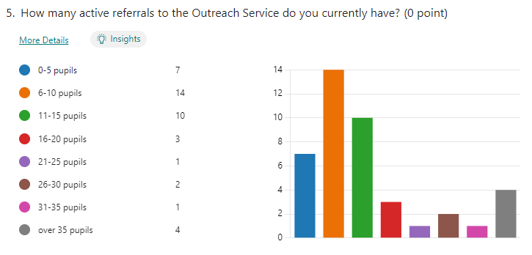
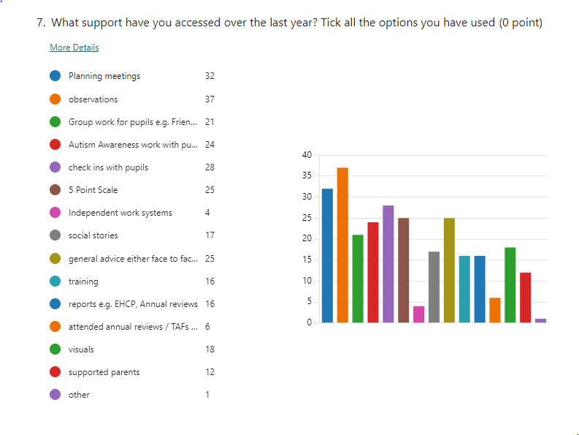
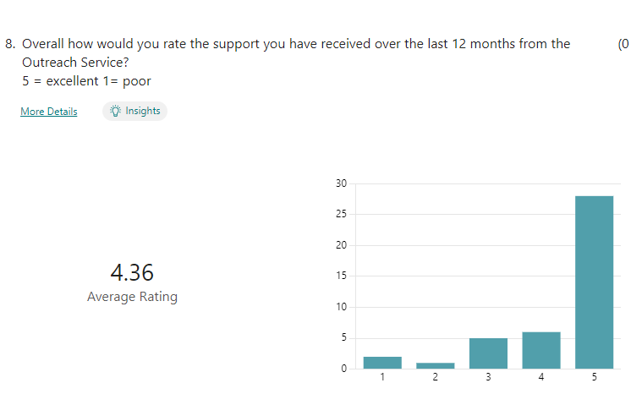
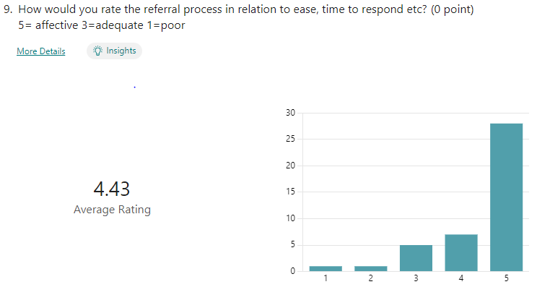
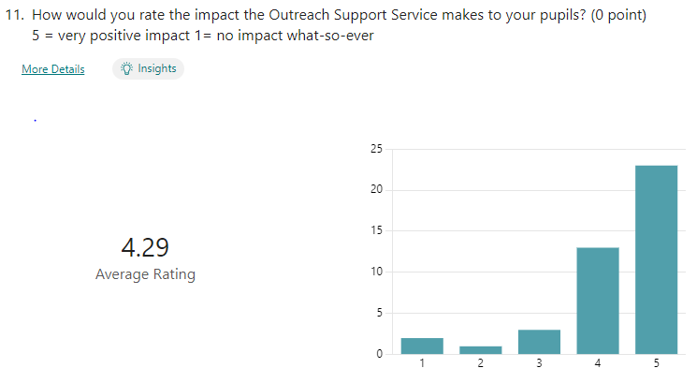
Comments about the online referral process:
“much easier”
“really quick and easy way for both settings and parents to complete. Parents prefer the online link the majority of the time”
“the referral process is really helpful and so much easier”
“the referral process is working fantastically well and I have no complaints about the process whatsoever”
“much faster and easier to refer”
“sometimes you do not get a response after making an online referral and I did not realise you had to send proof of evidence the child is on the waiting list or has a diagnosis before the child can receive outreach support”
Comments about the secondary triage system:
“triage system was very professional and completed in a timely manner with advice given alongside practical strategies of support”
“the system works better. Staff and pupil questionnaires completed in advance of the triage meeting help with tailoring the support to meet pupils’ needs effectively”
“new triage system is more efficient and allows us to understand what support is best for the student”
Comments about the online resources:
“really useful to have a central point to access for staff”
“very easy to access”
“they are a really good source for resources”
“Yes it is good to have a resource bank to call upon rather than having to bother staff all the time”
“Great – really helpful. More social stories would be ach – maybe editable versions now we have widget. Also TEACCH tray activity templates for different stages of development as I worry my ideas are a bit boring”
Comments about the pre-recorded training sessions:
“this has been much easier for our staff to access and has increased the volume of staff able to access the training in their own time”
“I love the narrations on there which complete the training for you”
“the new online training resources have been incredibly useful. This has allowed us to deliver the training at a time that works around our staffs schedule and has solved issues we had in the past in regards to training happening live over Teams”
“the right length to ensure engagement – useful for training session where people can access different things in allocated groups”
Ways we could improve the service:
“additional planning meetings and the ability to respond faster when support is needed, although I realise this is a staffing issue”
“more capacity to complete more regular visits and more intensive support”
“more staff and more resources when you can on your website as I have used that a lot”
“time between referral to observing young person could be shorter”
Some of the other general comments made:
“we always find the staff friendly and adaptable. They fit in with school plans and the children always respond positively to any sessions/visits”
“Ms Hannah Gibson-Matthews has been a vital professional colleague for our school this year. She has provided great expertise, advice, provision ideas and support for a range of different pupils and staff”
“it is an invaluable support service, thank you so much. Special shout out to Chloe Lawrence, she is extremely supportive and attends some of our SEND coffee mornings as well as visiting the children in our setting”
“Jenny has always been and continues to be incredibly supportive”
“you are all fabulous”
“Thank you – your support is invaluable in our setting and we really appreciate our working relationship with you”
Outreach Staff
This term we had two new support workers start with us as we were down to one support worker in September and she left in January. By the middle of this term we had 6 members of the Outreach Team. These consist of 4 teachers and 2 support workers. Of the four teachers we have 2x 0.8 and 2x 0.6 and of the support workers we have 2x full time. One teacher has the role of lead teacher for the Outreach Team. Due to changes in support staff this term has been training and induction for them. They will be taking on full caseloads in April. One support worker will support in Primary settings and one in Secondary settings.
Further information
The online new referral system has continued. We have received approximately 130 referrals over the term and 92 of these have been accepted as all the information required was received. We have started chasing up the referrals that have information missing and giving deadlines for completion. If the information is not received the pupil will be removed from the list.
We have continued to receive bookings for traded support this term for pupils in the East Riding.
We took two weeks away from settings this term to develop the outreach section on the school website. We have uploaded resources and information to support schools at the Universal level. This is to make sure our time is spent with pupils at the specialist and target levels of support. The links to resources have been shared with settings and we have received lots of positive feedback. These resources also link into the triage system that we are now using for secondary referrals. Rather than automatically going into the setting when a referral is accepted we now complete an online triage meeting and recommendations and strategies are suggested. If an observation is still required this will then be offered. Again we have received positive feedback about this approach for secondary settings.
Alongside the resources on our website we have also uploaded pre-recorded training sessions for schools to access. These have replaced our virtual training offer. We felt this was a more accessible offer for settings.
All our resources, information, guidance and recorded training feed into the Graduated Approach document produced by Hull City Council.
Jenny Clark
Lead teacher, Northcott Outreach Service

