Termly Report: Autumn Term 2023
Date: 15.01.2024
Numbers on our database (number in bracket is last quarters figure)
Section on the Database | Total number
Total number of pupils on the database | 1387 (1376)
Number of primary pupils | 755 (836)
Number of secondary pupils (including Ron Dearing and Hull College) | 614 (527)
Number of boys | 998 (1012)
Number of girls | 363 (2339)
Non-Binary / gender fluid / Agender | 26 (25)
Number of pupils with EAL | 115 (112)
Number of pupils with a diagnosis | 650 (675)
Number of pupils with an EHCP | 338 (367)
Number of pupils in red | 118 (141)
Number of pupils in yellow | 119 (150)
Number of pupils in green | 85 (85)
Number of pupils in purple | 110 (137)
Number of pupils in brown | 6 (2)

Key to colour coding on the database
Red | Targeted with planned support
Amber | One off visit then possibly targeted planned support
Green | Telephone/email/planning meeting support
No colour | No support needed at this time but are discussed termly at planning meetings between Outreach and the SENDCo
Purple | Initial observation then change to one of the above colours after the initial observation
Brown | Referred as part of support for the Autism Team. These pupils are not on the pathway but the school require support in meeting their needs

Headline data from the figures
We have already replaced all the year 11s we lost in July along with the pupils who moved to specialist settings. Historically it takes most of the academic year for the number of new referrals to catch up.
This is the highest number of pupils we have ever had on our database.
This is the highest number of secondary aged pupils we have ever had our database,
We received 175 new referrals last term which is the highest number for a term we have had since we started collating the data.
Training delivered
This shows the numbers that have attended our training this quarter.
Virtual training from our offer | Virtual training booked by individual settings | Face to face booked by individual settings
7 sessions ran  Attended by: 196 |  | 10 settings (2 secondary; 8 Primary plus a number of Early Years setting through the Early Years 3 day workshop  173 participants
This was the first time that we added an admin charge of £20 for non-attendance at a virtual training session without prior cancellation. Attendance increased.
Additional information
This table is the total for all staff this quarter.
Number of settings visited: | Number of pupils supported: | Number of meetings attended (number of pupils involved): | Number of new referrals received: | Number of EHCNA reports written | Number of other reports written
Early Years 2 | Initial observations 138  Targeted support 363  One off 358  Other 191 | 92 (632) | Early Years 7  Primary 102  Secondary 45College 0 | 38 | 147
Primary 181
Secondary 87
College 1

Virtual

Pupil absence – 27
Settings cancelled visits – 6
The secondary new referrals did not necessarily have initial observations as we are trialling a triage system. This reduced the number of visits to secondary settings.
Feedback from other professionals
A forms survey was sent to other agencies we work alongside. 6 completed questionnaires were received. This is a summary of the results.
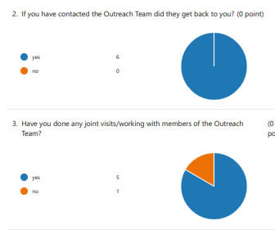
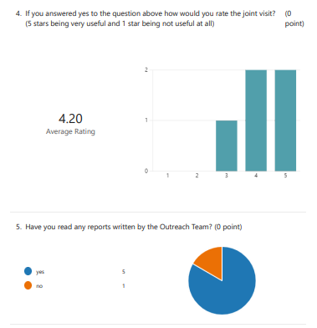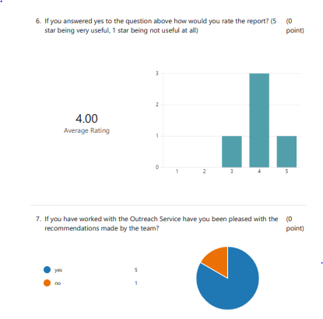
Some of the other comments made:
“The joint working between SLT an outreach is valuable and in my experience when working together this really supports settings and outcomes for the child/young person. Outreach is a great service and has offered lots of brilliant advice to settings and me!”
“Friendly, accessible and great advice service”

Outreach Staff
We currently have 6 members of the Outreach Team. These consist of 4 teachers and 1x 0.8 support worker. This is one less support worker than last term. Of the four teachers we have 2x 0.8 and 2x 0.6 and the support workers is x 0.8. Currently one 0.8 teacher and one 0.8 support worker provide the support for the secondary settings and the other staff provide the support for the primary and early years settings. One teacher has the role of lead teacher for the Outreach Team.
In January 2024 we will lose our level 3 support worker but hope to replace her with a full-time level 4 support worker. We will also be increasing our team with the addition of temporary posts funded through the “Delivering Better Value” bid that the LA secured. These roles will focus on transition support and specialist provisions.
Further information
We have seen another increase in new referrals – over 170. This has been using our new online referral system.
We have developed online resources on our website. Staff spent two weeks in the office putting together guidance and resources linked to the graduated response document. This has then been uploaded to the Outreach Service tab on the Northcott School website. It will be a work in progress but we have managed to get lots of resources and information on there already.
In our secondary settings we have trialled a triage system for new referrals in order for us to keep up with the high numbers we are receiving. This triage system means that we are not needing to complete an initial observation for all new referrals received. We have a virtual meeting with staff that know the pupil; forms questionnaires are sent to the pupil and staff and then during the triage meeting we discuss strategies and recommendations for the pupil. This completed form is then sent to the setting. The recommendation may be that we need to observe with the pupil. We have linked the strategies to the online resources we have created and the graduated response document from the LA. The rationale behind this is that we will be able concentrate our time when in settings to whole school environmental support and to pupils at the targeted and specialist levels. The pupils requiring universal support should be able to have their needs met by the setting with support from our online resources.
Next term we are looking at recording our virtual training sessions and adding them to the website so that they are accessible to schools at more convenient times and hopefully therefore will be more widely used. These recorded sessions will support the online resources we have developed.
Jenny Clark
Lead teacher, Northcott Outreach Service

