Termly Report: Summer Term 2023
Date: 06.09.23
Numbers on our database (number in bracket is last quarters figure)
Section on the Database | Total number
Total number of pupils on the database | 1376 (1253)
Number of primary pupils | 836 (730)
Number of secondary pupils (including Ron Dearing and Hull College) | 527 (510)
Number of boys | 1012 (930)
Number of girls | 339 (297)
Non-Binary / gender fluid / Agender | 25 (26)
Number of pupils with EAL | 112 (98)
Number of pupils with a diagnosis | 675 (668)
Number of pupils with an EHCP | 367 (336)
Number of pupils in red | 141 (148)
Number of pupils in yellow | 150 (136)
Number of pupils in green | 85 (93)
Number of pupils in purple | 137 (64)
Number of pupils in brown | 2 (2)

Key to colour coding on the database
Red | Targeted with planned support
Amber | One off visit then possibly targeted planned support
Green | Telephone/email/planning meeting support
No colour | No support needed at this time but are discussed termly at planning meetings between Outreach and the SENDCo
Purple | Initial observation then change to one of the above colours after the initial observation
Brown | Referred as part of support for the Autism Team. These pupils are not on the pathway but the school require support in meeting their needs

Training delivered
This shows the numbers that have attended our training this quarter.
Virtual training from our offer | Virtual training booked by individual settings | Face to face booked by individual settings
63  (only 3 sessions this term) |  | Froebel – 16  Marvell – 65  Kingswood Parks – 35  Cavendish – 22  St Thomas – 62  St James – 13

This term we had Early Bird running with 3 parents attending. This ran for half a day with one member of the team delivering it. Early Bird is 10 sessions.
Additional information
This table is the total for all staff this quarter.
Number of settings visited: | Number of pupils supported: | Number of meetings attended (number of pupils involved): | Number of new referrals received: | Number of EHCNA reports written | Number of other reports written
Early Years 7 | Initial observations 128  Targeted support 177  One off 423  Other 216 | 63 (183) | Early Years 4  Primary 109  Secondary 23  College | 37 | 129
Primary 284
Secondary 64
College 1

Virtual

Buddy, our therapy dog attended 8 settings.
Pupil absence – 36
Settings cancelled visits – 10
This term the teacher strikes impacted again on visits as most visits planned for those days were cancelled, particularly in Secondary Schools, as pupils were not in school. We lost one member of staff for the last 4 weeks of the summer term. One member of staff had a period of absence due to illness.
Feedback from pupils
A forms survey was sent to all settings. 36 responses were received from 83 settings. This is a summary of the responses:
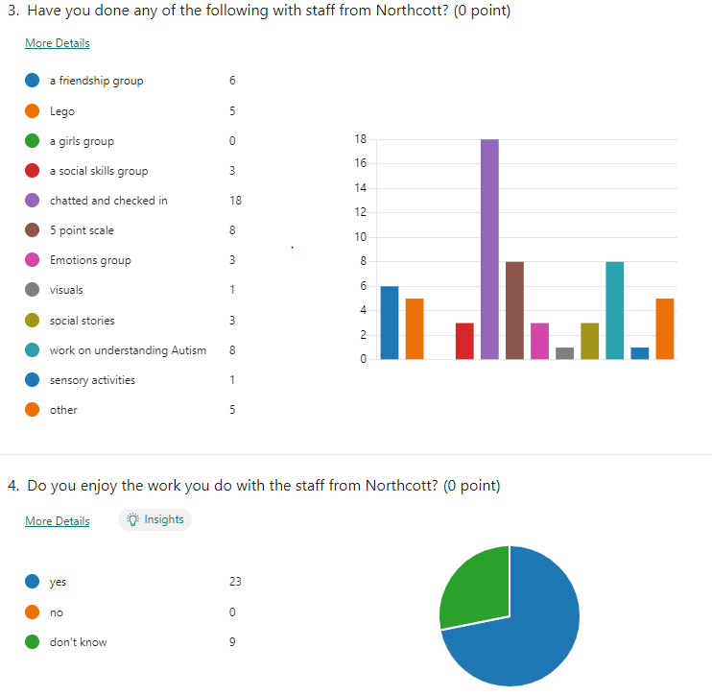
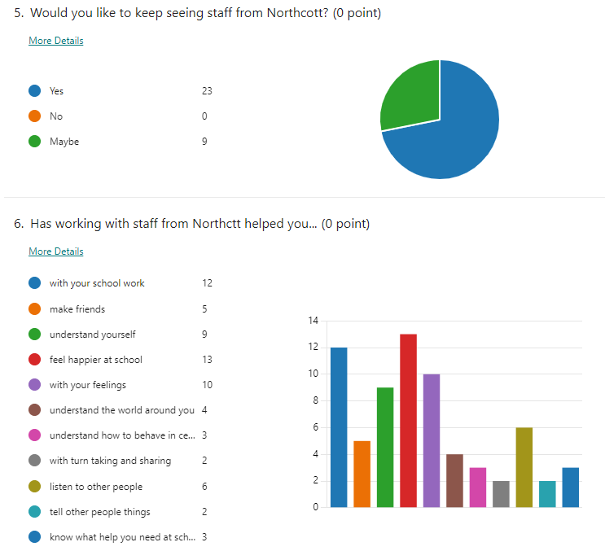
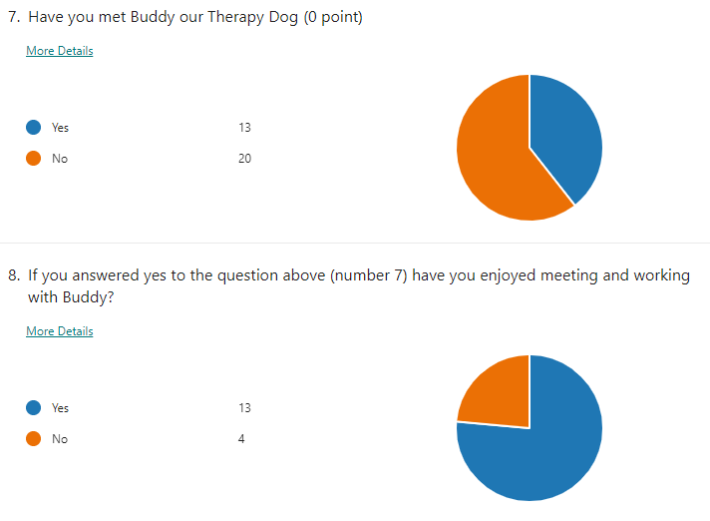
Some of the other comments made:
“That there nice and help me”
“I would like to meet them more often”
“My son has really enjoyed seeing Sarah, he’s really struggling to settle into year 7 so it’s been a big help and really looks forward to his session especially seeing Buddy. “
“Thank you for your help”
“I’m very grateful that you come to my school”
“I feel I have benefited greatly from the visits from Northcott staff particularly when they bring my friend Buddy. I would very much like to participate more with Buddy and take part in any other activities with Northcott.”
Outreach Staff
We currently have 6 members of the Outreach Team. These consist of 4 teachers and 2 support workers. Of the four teachers we have 2x 0.8 and 2x 0.6 and of the support workers we have 1x full time and 1x 0.8. Currently one 0.8 teacher and one full time support worker provide the support for the secondary settings and the other staff provide the support for the primary and early years settings. One teacher has the role of lead teacher for the Outreach Team. One member of support staff left at the end of June.
Further information
We have seen another increase in new referrals – over 130. We stopped accepting referrals in the middle of June so that we could make sure we saw or booked in all new referrals before finishing in July. We are launching a new online referral system from 1st September 2023.
We have continued to receive bookings for traded support this term from private settings and for East Riding pupils.
The Therapy dog continues to be very popular with both staff and pupils. As the dog is owned by the secondary outreach support worker it is mainly secondary schools that are accessing this. Unfortunately due to reduced staffing levels in September we have had to remove this support from our current offer. This will be reviewed at the end of the Autumn Term.
This term we were very busy with transition. We visited all year 6 pupils (155) during the summer term in their primary schools and during transition week in their secondary schools.
Jenny Clark
Lead teacher, Northcott Outreach Service

