

NORTHCOTT SCHOOL

Relational Policy
(Formerly known as the Behaviour Policy)

Created By: | Lead Practitioner for Pastoral Progress
Approved By: | Awaiting approval by Governing Body
Version: | 1
Created on: | May 2023
Amended on:
Next review date: | 3 years (or any changes in legislation)

Introduction

Northcott School and Sixth Form College is invested in creating a school community that focuses on pupil wellbeing, as we recognise that wellbeing and behaviour are inextricably linked. We know that a strong focus on a pupil’s wellbeing increases the opportunity for our pupils to achieve their full potential. This approach will support our young people in understanding and developing their social and emotional needs in order to have a positive place in society. We have developed a Relational policy that has placed relationships at the centre of our focus so our young people can thrive in all areas of their lives.

We recognise that behaviour is a form communication, it is therefore all stakeholders’ right and responsibility to listen to the needs a young person is expressing through their behaviour, whilst setting clear boundaries and expectations. We recognise that our pupils have a wide range of Special Educational Needs which can make it increasingly complex to self-regulate, it is therefore imperative we manage their behaviour in a positive manner, using the knowledge of their needs to support their resilience.

Guided by the Thrive Approach, we focus on relational connection and regulation first. We do this by putting relationships at the heart of our approach by listening and responding to our children’s voices, to create and maintain a safe and happy environment where all feel safe, secure and respected.

Aims
- To teach our young people how to communicate, self-regulate and express their feelings and emotions in a way that will support them in their adult life.
- To ensure that all members of the school community provide a safe, nurturing environment, using responsibility, PACE (Playfulness, Acceptance, Curiosity and Empathy) to foster appropriate behaviour.
- To encourage our young people to build and maintain positive, trusting and rewarding relationships that will facilitate effective learning and support with their futures.
- To develop resilient, compassionate and empathetic young people.

Purpose of the Relational Policy
To provide guidance to all stakeholders that is:
- Clear and easy to understand and be used to provide a safe, nurturing environment, using responsibility, PACE (Playfulness, Acceptance, Curiosity and Empathy) and Vital Relational Functions (VRFs) to foster appropriate behaviour. See appendix 1.
- Used to create a consistent approach towards embedding a nurturing and inclusive whole school ethos that achieves the aims of this policy.
- Used to ensure pupils can learn effectively to achieve their full potential.

Managing behaviour relationally: The Thrive Approach
At Northcott School and Sixth Form College we strive to demonstrate a relational approach to supporting social and emotional development based on the following key principles of the Thrive Approach:
- We understand behaviour communicates unmet needs whether they are linked to their SEN or SEMH needs. We separate the behaviour from the young person and use their EHCPs and Thrive action plans to accurately understand what is needed.
- We acknowledge the distinction between shame and guilt and recognise that shame prevents healthy emotional development.
- We understand that each development stage has a range of typical behaviours which adults can use to role model and teach appropriate behaviours. In addition to this we understand that through adolescence these behaviours may recycle early unmet needs and pupils may need support with this.
- We provide containment, predictability and routine to build a sense of safety in the emotional and physical environment. This is especially important with our pupils who have ASD needs.
- We encourage our pupils to be accountable for their actions and the impact they have on themselves and others. This solution focused approach supports future changes.
- We recognise that all our pupils are at different stages of the developmental process. We don’t make judgements, we support and guide our pupils to make appropriate choices.
- We seek to repair relationships and change behaviours rather than punish the actions a child has taken. This does not exclude the use of sanctions as consequences.
- By supporting the growth of emotional development and self-regulating skills pupils can learn to improve behaviour.
- Supporting pupils to communicate effectively and appropriately is a very important way to promote them to self-regulate, build resilience and behave in a positive manner.
- All incidents will conclude with a restorative conversation in order to repair the relationship with the staff member of whom the rupture occurred.
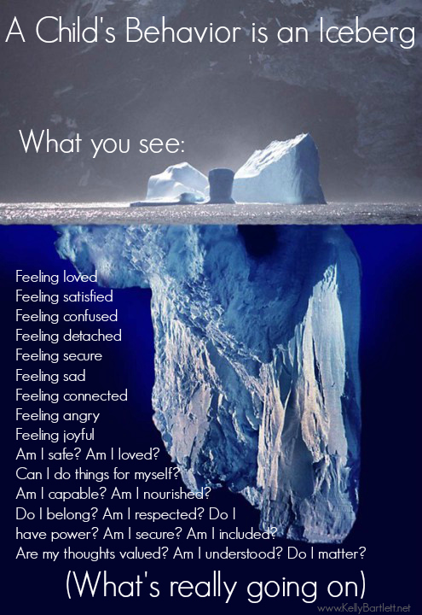

Northcott School’s Relational Policy is based on the knowledge that all behaviour is communication of an unmet need.

Consistency and Leadership
The Head teacher has the overall responsibility to ensure this policy is being adhered to. The Lead Practitioner (LP) for Pastoral Progress has the responsibility to support with the consistency of applying this policy across the school. The LP will ensure that staff have the knowledge and support required to embed trauma informed practise using the THRIVE Approach.
The pastoral support team are responsible for ensuring the Relational Policy is consistently applied day to day. Their roles include onsite support with classroom management, incident support, monitoring behaviour and implementing interventions that are evaluated regularly.
All staff have a responsibility to ensure they are following this Relational Policy. All staff will model positive behaviour to pupils, use positive language that takes a PACE approach and uses the Vital Relational Functions (VRFs) as stated in the Thrive Approach (see appendix 1).
To achieve the aims of this policy we will all:
● provide a clear set of agreed rules, rewards and consequences through consultation with staff, school council and pupils;
● ensure the above are clearly displayed for all so that everyone is clear about what is expected and approaches to behaviour management are consistent across the school;
● ensure that there are consistent nurturing practices across the school;
● ensure a Thrive Approach is embedded across the school so that the mental health and wellbeing of pupils and staff is a priority;
● ensure that children understand the meaning of inappropriate and unsafe behaviour that includes discrimination and bullying and know how the school will deal with it.

Senior Leaders will:
- Meet and greet off the buses each morning and be at the buses to say goodbye at the end of the day
- Be visible and positive
- Be visible at transition times including lunch time
- Engage in learning and well-being walks to see positive behaviours, provide support and model expectations
- Ensure restorative conversations and de briefs take place
- Support staff in managing children with more complex behaviours
- Regularly review provision for children who find their regulation a challenge
- Ensure that the Relational Policy is consistently followed

Classroom Management
We understand that all behaviour is a communication, and this is the area of need for a large majority of our pupils. We encourage positive behaviour through our communication of high expectations, adaptive teaching that meets the varying SEND needs of our pupils and through establishing positive relationships between staff and pupils.
At Northcott School all pupils are expected to:
- Be respectful
- Be patient
- Be productive
- Be your best

These expectations are clearly displayed in classrooms and communal spaces in two different formats to cater for the differing needs of the pupils. Staff reinforce these expectations as part of the classroom management daily in lessons. (see appendix 2)
All classes have a dynamic seating plan to support pupil’s physical containment. Pupils needing attuning to, in order to support with their behaviour, are identified on seating plans. It is the responsibility of the class teacher to proactively direct teaching assistants to support the needs of all pupils across the school.
On the playground, pupils find unstructured time challenging. Playground rules are shared with pupils and are displayed on the playgrounds so staff can refer to these expectations. Break times are highly staffed, with radios for support if needed. Staff are expected to engage with pupils at break times and ensure they are monitoring the whole area between them.
All staff every day will:
- Promote a positive culture
- Adapt the learning to support pupil’s needs whilst engaging and challenging
- Build relationships by using the VRFs, and PACE
- Greet children in a morning in the classroom, at the start of lessons, and ‘check out’ at the end of the day
- Be consistent in applying the rewards system
- Model positive behaviours and always highlight the behaviour we want to see positively
- Always remind children of the expectations

Organisation
The pupils at Northcott need structures in place that are embedded into daily routines. These need to be upheld and modelled by all members of staff both in classrooms and around school. Routines include:
- Walking around the school behind a member of class staff to lessons
- Lining up to wait to enter a classroom until told to enter
- Using the quiet room, a sensory break or ELSA area if struggling to regulate
- Taking coats off in lessons and dining hall
- Wearing school uniform

Facilities
All classrooms have access to an identified area for pupils to have ‘time to think’ if needed at any given time of the day. These are equipped with sensory supports if required to support regulation.
Sensory Plans and Positive Handling Plans indicate areas of the school that a pupil may need to use to support their emotional or sensory regulation. These areas may include:
- Sensory hall
- Trampoline
- Immersive sensory room
- ELSA area
- Garden area
- Sensory garden
- Planned outside area

Incidents and Discriminatory Behaviours
Everyone at Northcott School has the right to feel safe and secure. Incidents and serious incidents will be recorded on Behaviour Watch and actions will be monitored for consistency. A whole school tracking system is in place to analyse these behaviours to monitor for patterns to ensure timely interventions are implemented.
An incident is defined as:
- Work avoidance/refusal.
- Low level disruption.
- Not following classroom expectations.
- Not following adult direction.
- Lesson refusal.

Pupils are highlighted if they have a set number of incidents recorded over a term. A serious incident is one that:
- Physical assault on an adult or child.
- Serious threatening behaviour with or without a weapon.
- Absconding from site.
- An incident that positive handling has had to take place to keep everyone safe.

The school behaviour tracker is updated fortnightly using Behaviour Watch data. The tracker uses a RAG rating system and clearly indicates what level of need a pupil is at throughout the year. Red focus pupils are those that have had 10 or more serious incidents recorded, Amber focus pupils’ record 10 or more incidents over a term. These pupils are monitored and have bespoke interventions in place to support their social communication, emotional and mental health development (SEMH).
Incidents of bullying and discriminatory behaviours are not acceptable and will be reported on Behaviour Watch and to the pastoral team. These behaviours will be shared with parents immediately and a programme of learning will be created to educate if it is repeated. Victims of these behaviours are also offered support through their tutor groups and pastoral team.

Behaviour Support
Team Teach, Positive Handling Plans, Behaviour Support Plans and Risk Assessments (see appendix 3)
Rewards
The best form of behaviour intervention acknowledges and enhances the positive. The use of effective praise that focuses on the process and effort rather than the outcome is key to building pupils self-belief.
We reward the process of learning through awarding points at the end of each lesson and rewarding tokens ‘in the moment’. This ensures the pupils are able to clearly identify the key skills and attributes that they have shown, leading to intrinsic motivation, resilience and lifelong learning.
Pupils collect their own points and can choose to save or buy a prize from the school shop, teaching life skills at every opportunity.

Consequences
Although we understand the behaviour of a child is communicating an unmet need it is important that when we are ‘Shining a Light’ on behaviour, attuning to their needs and separating the behaviour from the child, that we are highlighting unacceptable actions.
Pupils need to understand cause and effect, that their actions have consequences. At Northcott we use a ladder of consequences that is displayed in classrooms, and created in conjunction with the school council. This clearly maps out the stages and levels of possible consequences depending on the seriousness of the behaviour. (see appendix 4)
Consequences are decided upon by staff at the level of the behaviour. It is ensured that this is logical to the situation it occurred in e.g: If a child does not complete their work, they will use their own time to complete it.

Thrive Profiling
Each class in school have a Thrive Profile completed in the first half term. This highlights the emotional level of development of the cohort. This data is used to create a class action plan with activities to support the emotional development at a class level. This profile is repeated again in the Spring and Summer Terms.
The class profiles are used to identify individuals that need reparative support in a small group or 1.1.

Tutor/SLT Reports
As an intervention, some pupils may be supported with a report of agreed targets of appropriate behaviours, that will be monitored, and shared amongst staff and parents. There is a set format for this (see appendix 3). Depending on the data available a pupil may have an SLT report to which they will report to a member of SLT.
We understand that some pupils may have a sense of shame by having a report. Considerations for implementing a report are taken on an individual basis. Pupils on report are recorded on the whole school tracking system.

Relational Support Plans
Pupils that continue to be dysregulated regularly will have a Relational Support Plan implemented. This plan is set up involving parents, pupil, pastoral support lead and tutors. Behaviours of concern are discussed and interventions/targets (maximum of 3) are agreed by all in the meeting. This is reviewed at least 6 weekly by the pastoral support team. Behaviour support plans aim to reduce the number of recorded incidents in a supportive way. External agencies may become involved at this stage if required. The meetings focus on discussions with those that know the young person well in order to be curious as to the reason for the behaviour.
The action plan is implemented at this stage when Wave 1 Universal measures have not been successful in improving a child’s behaviour (Appendix 5 shows a hierarchy of support and interventions offered at Northcott School). The purpose is to promote well-being and help to reduce the need for suspension or exclusion. A Thrive assessment and action plan will be used to support the identification of the barriers to positive behaviour.

Team Teach
All school staff are Team Teach trained to Level 2. We have two members of staff that are Team Teach instructors who can offer support if required. The exceptions to those being Team Teach trained are the Emotional Literacy Support Assistants (ELSA) as it would be detrimental to the work they do if they had to positively handle a pupil. The focus of Team Teach is on de-escalation and co-regulation with trusted adults. Staff use Team Teach alongside PACE and VRFs.

Change of Face/additional Support
We operate a system across school using radios to communicate for further advice/support or a change of face. The whole school communication channel is 6 and behaviour support is channel 11. A member of the pastoral support team will always have a radio on channel 11 to respond for support.
All staff must ensure they have a radio in these situations to safeguard themselves and pupils:
- Teacher on duty on the playground at break time.
- Identified member of staff in lunch activities.
- When leaving the classroom to support the needs of a pupil that is dysregulated.

Positive Handling Plans
Positive Handling Plans (PHP) are designed to be a live document to support the planning for pupils that need support with their behaviour. Pupils that have a repeated number of incidents recorded on behaviour watch or require positive handling are given a PHP. The PHP highlights strategies that work well to maintain regulation, and strategies to minimise the need for physical intervention, at varying levels, in response to behaviours. It is also designed to ensure staff can take a more proactive approach to behaviour by trying to understand that it is communicating. All PHPs are available to be seen by the whole staff team on Behaviour Watch. They are updated at least termly, however are to be reviewed following a serious incident. PHPs are shared with parents termly.

Risk Assessments
Risk Assessments are implemented for a pupil whose behaviour has the potential to put themselves and others at risk of injury or serious harm or for safeguarding. A risk assessment is carried out by staff who know the pupil well. A RAG rated system is used against a series of risks to highlight situations that are of high risk. This can then be used to plan and make modifications to the provision in place if needed. A risk assessment can be used alongside toolkits, such as Sexual Harm toolkit, which enables analysis by age.

More Serious Behaviour Incidents
Internal Isolation
An internal solation may be appropriate to support learning and ensure child safety. A child internally isolated would not have contact with their class but instead have specific well-being support focusing on social, emotional and behavioural skills and their education would continue.
Suspension
Serious incidents need to be treated on an individual basis and the circumstances investigated. Any suspension would follow Government guidance. It could be for a first offence or a series of incidents including for example:
- Serious deliberate damage to school property
- Serious actual or threatened violence against another pupil or a member of staff
- Patterns of discriminatory behaviour
- Sexual abuse or sexual harrassment
- Bringing in an illegal drug
- Bringing in an offensive weapon

Reasonable adjustments will be made according to Code of Practice (2015) and Equality Act (2010). In this situation, working alongside the parents to agree targets and ways forward are key as part of a reintegration meeting. Planning to support a child reintegrate back to lessons will be taken into consideration. The Local Authority will be made aware of suspensions by using the LA Suspension Reporting Form.

Permanent Exclusion
In a situation where the behaviour is serious enough to result in a permanent exclusion Government Guidance will be followed. This could be an isolated incident or an accumulation of incidences over time. The Local Authority are to be made aware of this. Evidence will be collated and the case will go to a Governors’ panel meeting. The outcome of this meeting will be to uphold the decision or reinstate the pupil.

Exclusion Guidance (May 2023) for children with a social worker outlines requirements for Head teachers to inform social care colleagues of both suspension and exclusion, on the same day, and to ensure they are invited to review panels.

Staff Development and Support
As the Thrive Approach is at the heart of our Relational Policy we ensure that we have a programme of CPD that we keep revisiting to upskill our staff. This CPD may take the form of:
- In school staff meetings
- External Thrive Practitioner courses
- External emotional well-being courses
- Learning walks and feedback
- Thrive profiling observation support

Using the behaviour and safeguarding data that we have available, we tailor the CPD that is needed using this information so that we are best equipped to meet the needs of our cohorts.
New staff to Northcott, as part of the induction process, are required to have training on Safeguarding, ASD, Team Teach and the Thrive Approach.

Pupil Support
Using PSHE to support understanding of relationships
At Northcott we feel that delivering Personal, Social and Health Education can support with establishing positive and healthy relationships. All pupils at Northcott have access to a PSHE programme of learning using the Jigsaw scheme of work. This scheme is adapted and delivered to tutor groups in a two hour session each week. This programme ensures that all pupils have access to the statutory curriculum. Each unit is assessed and this data is forwarded on annually to support planning the following year. The data is also used to identify individuals that may need extra support.

ELSA and Reparative Thrive
We have a pastoral support team who deliver bespoke well-being and relational support, and interventions to a number of pupils who are identified by their class staff. Staff in the pastoral team are either trained in ELSA (Emotional Literacy Support) or a Thrive Practitioner.
Pupils initially have a Thrive Assessment to assess their development stage. If a pupil is screened at the Thinking Stage of development then they will access an ELSA intervention possibly alongside reparative Thrive. An ELSA assessment will take place to monitor the progress throughout the series of sessions.
Reparative Thrive is used when a child has interruptions in their development that is causing them to become dysregulated regularly. A pupil will have a Thrive profile carried out and an action plan created for school and for home. This action plan will be updated as decided by the Licensed Practitioner.

See appendix 5: response to need document. This document maps clearly the support we offer pupils at wave 1-3 as interventions.

Thrive Ambassadors/Peer Mentors
We recognise that occasionally pupils don’t feel able to communicate to adults but would prefer to speak with a peer. We have a peer mentoring scheme and Thrive Ambassadors across the school who are trained to support pupils. They know what their role is and who to report to following a pupil needing support from them.

External agencies
Where a child’s behaviour has not improved following targeted support, we engage external agencies to assist us.
Agencies involved could include:
- Educational Psychologist
- CAMHS
- Hull Thrive
- Mental Health Support Teams
- MIND
- Time 2 Listen
- EWO (Education Welfare Officer)
- Early Help
- MESMAC
- Corner house
- Virtual School
- Social Care
- VEMT

This list is not exhaustive, the needs of the child will dictate which support is required. Parents will be informed and their views and consent sought should the school refer to one of the above agencies.

This Relational Policy needs to be read in conjunction with other school policies and documents:
- Keeping Children Safe in Education
- Safeguarding and Child Protection Policy
- Anti-Bullying Policy
- Mental Health and Well Being Policy
- Northcott School’s Home School Agreement
The Relational Policy refers to DfE statutory guidance and documents that should be read alongside this policy. These include:
- School Suspensions and permanent exclusions Sept 2023 updates
- Behaviour in Schools Sept 2022 update
- The Education and Inspections Act 2006
- Exclusion from maintained schools, Academies and pupil referral units in England 2012
- DfE Dealing with allegations of abuse against teachers and other staff

Appendix 1
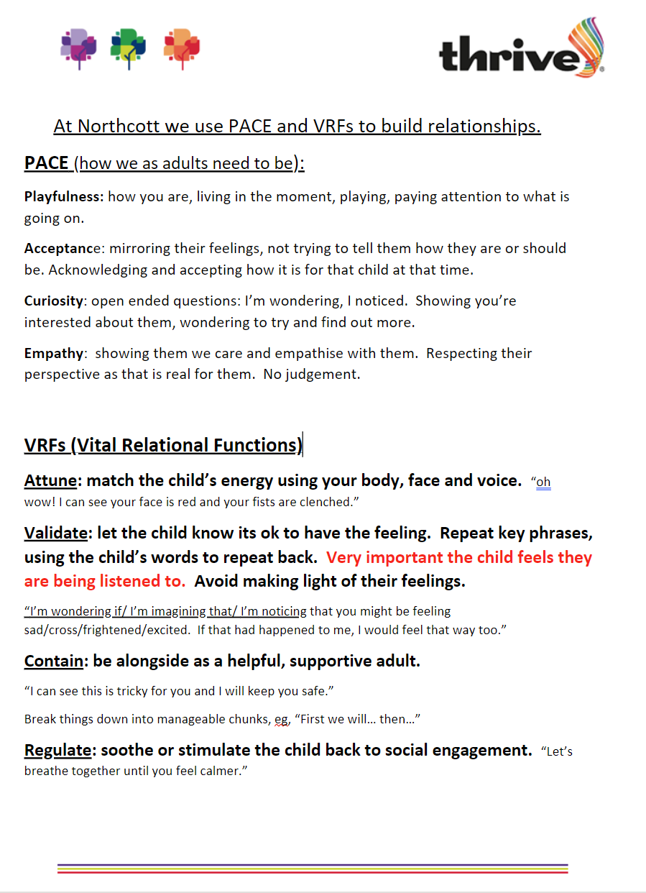

Appendix 2
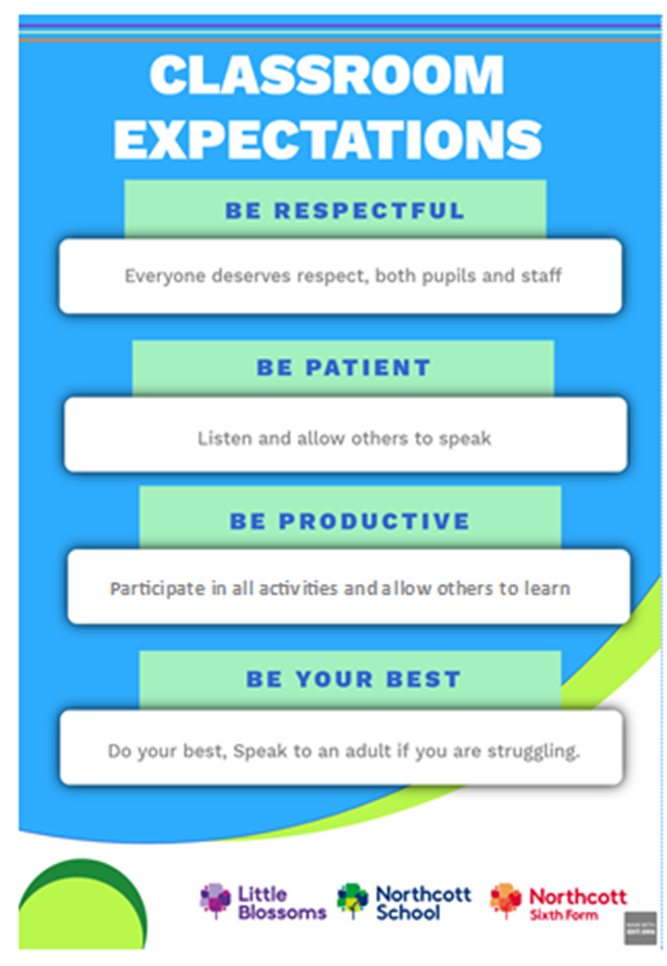

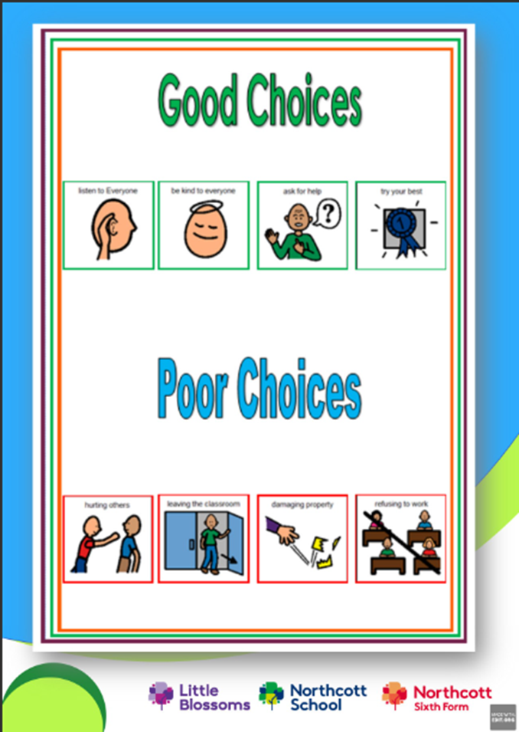

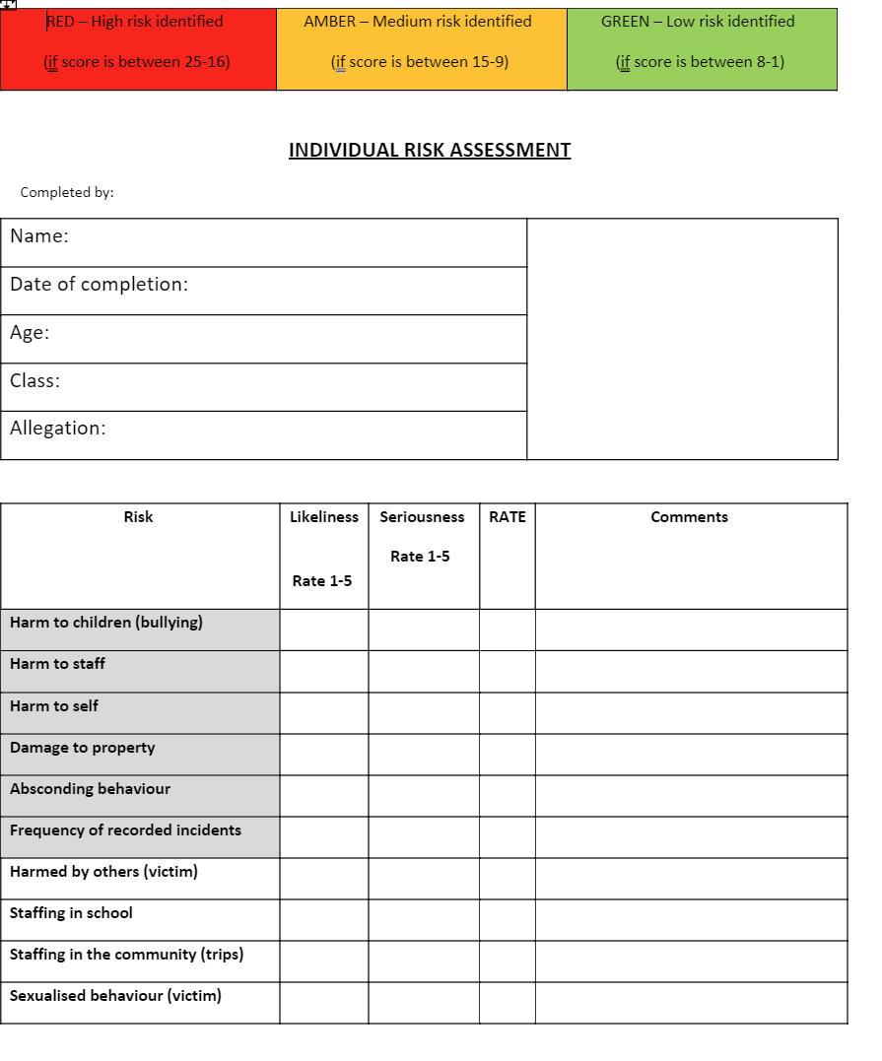
Appendix 3
Rate the likeliness and seriousness of risk (1 = low, 5 = high)
Multiple both risks to give the overall score = RAG rating.

Risks to be managed:

Mitigate Risk

Staff Details:
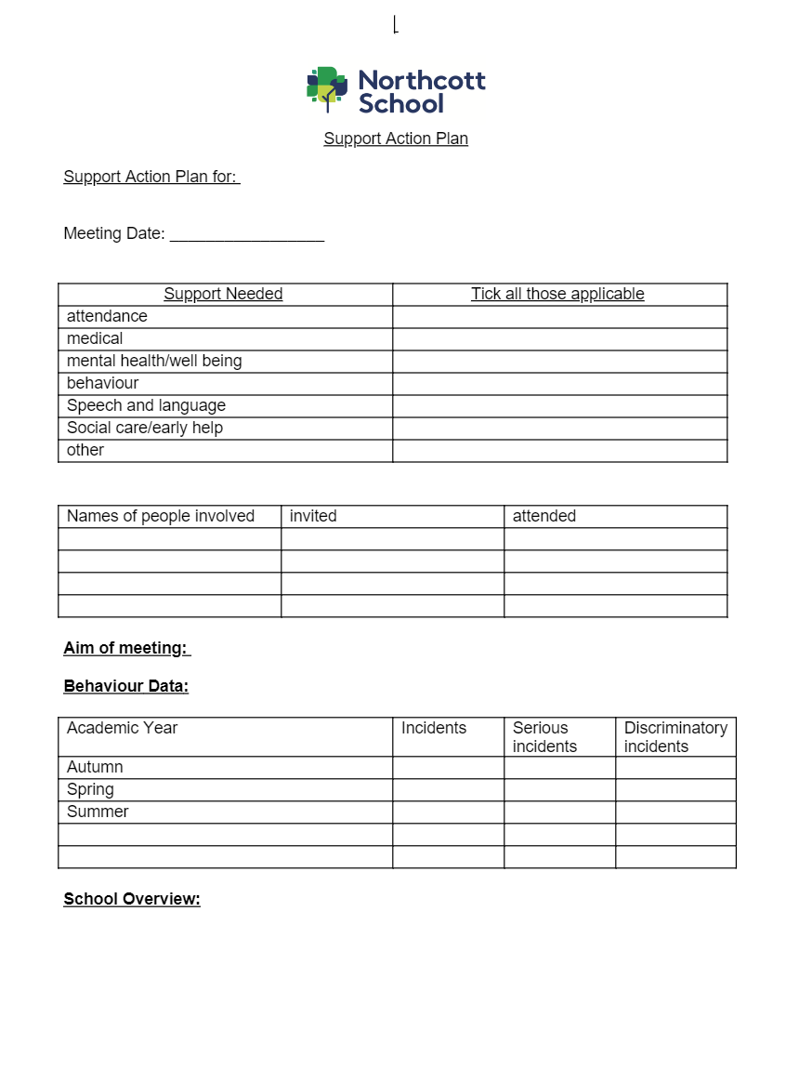

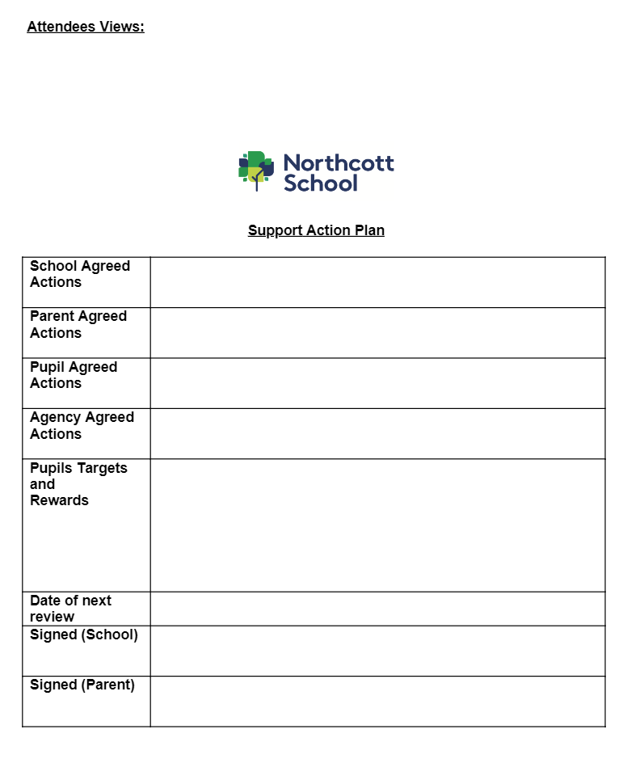

Appendix 4
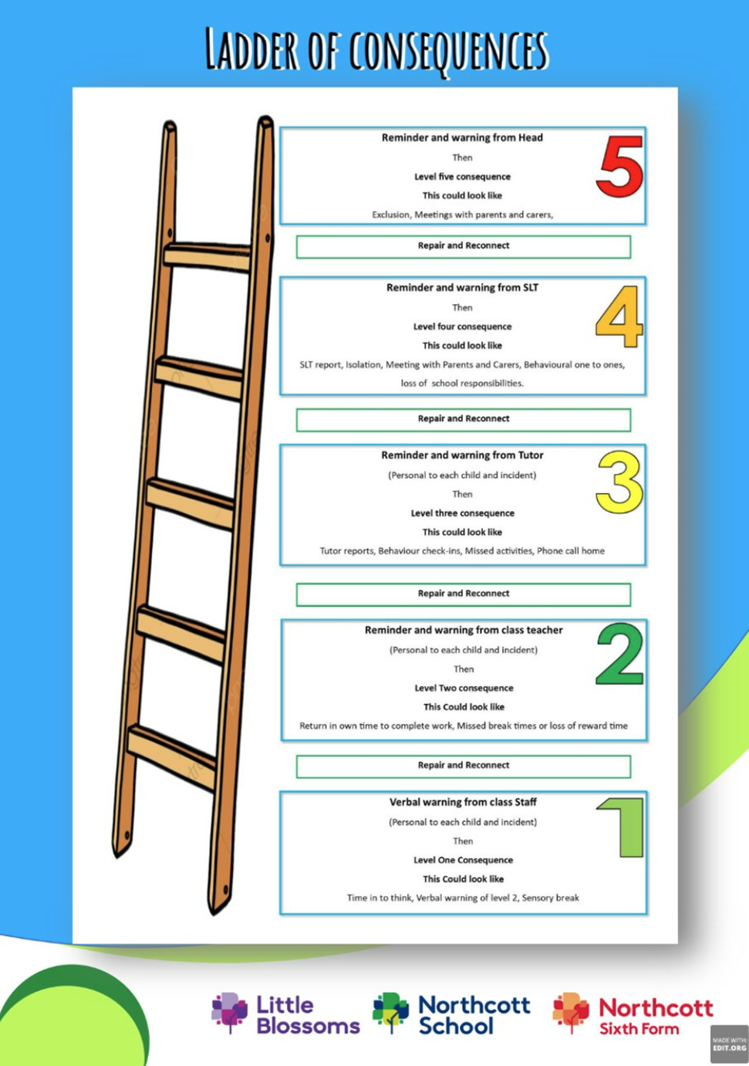

Appendix 5: RAG hierarchy of support and intervention at Northcott School.
Wave 3  High level need  Specialist support for complex needs. | 10+ incidents in a term/exclusions  Personalised curriculum within school.  Support action plan to identify needs behind behaviour.  Individual risk assessment.  Referral for:  A is for Autism delivered 1.1.  CAMHs  Educational Psychologist  HART assessment  Time 2 listen  Individual Thrive profile and action plan delivered by Childhood Practitioner.  Hot spotting individual timetable.
Wave 2  Targeted intervention | 7-10 incidents in a term  Meetings with key groups of pupils to set targets and discuss successes.  Behaviour Management Plan  Referral to ELSA  Social skill and friendship groups  SLT reports  Individual Thrive Profile and action plan delivered by class team.  Class Tutors to implement interventions to support needs.
Wave 1  Universal Provision | All classroom staff level 2 Team Teach trained.  Class management strategies.  Hot spot walks.  Whole school reward token system.  Behaviour watch tracking.  Social skills  Tutor reports  Thrive class group profiles and action plans created.  Class expectations and ladder of consequences for consistency.  Use of PACE and VRFs.  Repair and reconnect after incident.
 | Behaviour

