Data Pack

EOY 2022-23

**Northcott School and Sixth Form College**

EOY Data Report

Headline Figures

* Due to different assessment pathways used in school, this data analysis reflects a cohort of 128 pupils across the Primary, and KS3 who are assessed using Progression Steps and KS4 students assessed using their accreditations achieved.

|  |
| --- |
| * Highest achieving year group overall is year 5. * Highest achieving KS4 group is 10a. * Largest percentage of children achieving above their target is in Speaking and Listening. * Highest achieving year classes and year group in Reading are the Primary and Year 8. * Highest achieving groups in Writing are 7a and 8a. * Highest achieving group in Maths Number and Measure is Primary. * Highest achieving group in Science is 8a. * Highest achieving group in Humanities is 7a. * PP Pupils out perform their peers across Speaking and Listening, Reading and Writing. * Disadvantaged groups out perform their peers in Reading and Science. * FSM pupils out perform their peers in Reading, Writing and History. * Pupils Open to Social Care out perform their peers in Maths Measure. * Disadvantaged pupils out perform their peers Science and Reading. |

**Definitions:**

**Sustained progress:** Progress made towards their End of Year target step.

**Substantial progress:** Progress above their End of Year target step.

|  |  |  |  |  |  |  |  |  |  |  |  |  |  |  |  |
| --- | --- | --- | --- | --- | --- | --- | --- | --- | --- | --- | --- | --- | --- | --- | --- |
| **Substantial Progress Whole School** | | | | | | | | | | | | | | | |
| **S&L** | | **Reading** | | **Writing** | | **Number** | | **Measure** | | **History** | | **Geography** | | **Science** | |
| **Pupils** | **%** | **Pupils** | **%** | **Pupils** | **%** | **Pupils** | **%** | **Pupils** | **%** | **Pupils** | **%** | **Pupils** | **%** | **Pupils** | **%** |
| 88 | 69% | 84 | 66% | 84 | 66% | 82 | 64% | 49 | 38% | 36 | 30% | 42 | 35% | 79 | 65% |

**Class group comparison**

**English and Maths**

|  |  |  |  |  |  |  |  |  |  |  |
| --- | --- | --- | --- | --- | --- | --- | --- | --- | --- | --- |
|  | S&L | | Reading | | Writing | | Number | | Measure | |
| Class | On  Target  % | Above Target  % | On Target % | Above  Target  % | On Target % | Above Target  % | On Target % | Above Target % | On Target % | Above Target % |
| Primary | 100% | 100% | 100% | 100% | 100% | 88% | 100% | 100% | 100% | 75% |
| Provision | 100% | 50% | 100% | 83% | 100% | 67% | 100% | 50% | 100% | 33% |
| VG | 100% | 43% | 100% | 14% | 100% | 71% | 100% | 43% | 100% | 43% |
| 7a | 100% | 100% | 100% | 100% | 100% | 100% | 100% | 83% | 100% | 17% |
| 7b | 100% | 100% | 100% | 91% | 100% | 91% | 100% | 91% | 100% | 0% |
| 8a | 100% | 100% | 100% | 100% | 100% | 100% | 100% | 78% | 100% | 0% |
| 8b | 100% | 100% | 100% | 100% | 100% | 80% | 100% | 90% | 100% | 60% |
| 9a | 100% | 56% | 100% | 56% | 100% | 56% | 100% | 56% | 100% | 56% |
| 9b | 100% | 50% | 100% | 17% | 100% | 33% | 100% | 58% | 100% | 50% |
| 10a | 100% | 83% | 100% | 92% | 100% | 75% | 100% | 67% | 100% | 67% |
| 10b | 100% | 30% | 100% | 30% | 100% | 30% | 100% | 90% | 100% | 90% |
| 11a | 100% | 40% | 100% | 40% | 100% | 40% | 100% | 10% | 100% | 10% |
| 11b | 100% | 42% | 100% | 33% | 100% | 33% | 100% | 25% | 100% | 25% |

**Humanities and Science**

|  |  |  |  |  |  |  |
| --- | --- | --- | --- | --- | --- | --- |
|  | History | | Geography | | Science | |
| Class | On  Target  % | Above Target  % | On Target % | Above  Target  % | On Target % | Above Target  % |
| Primary | 100% | 100% | 100% | 100% | 100% | 100% |
| Provision | N/A | N/A | N/A | N/A | 100% | N/A |
| VG | 100% | 67% | 100% | 83% | 100% | 33% |
| 7a | 100% | 100% | 100% | 100% | 100% | 100% |
| 7b | 100% | 64% | 100% | 100% | 100% | 100% |
| 8a | 100% | 22% | 100% | 56% | 100% | 100% |
| 8b | 100% | 0% | 100% | 0% | 100% | 80% |
| 9a | 100% | 0% | 100% | 0% | 100% | 78% |
| 9b | 100% | 0% | 100% | 0% | 100% | 67% |
| 10a | 100% | 0% | 100% | 0% | 100% | 42% |
| 10b | 100% | 0% | 100% | 0% | 100% | 10% |
| 11a | 100% | 30% | 100% | 0% | 100% | 60% |
| 11b | 100% | 0% | 100% | 0% | 100% | 17% |

For 10b, percentages for Speaking and Listening, Reading and Writing are reflective of students achieving a pass or fail in their qualifications. Students making sustained progress have passed their entry level or functional skills qualifications.

* 92% of students made substantial progress in 10a in Reading.
* 42% of students have outperformed their targets in their GCSE Spoken Language assessment results in 11b.
* 100% of students in the Primary and Year 8 are making substantial progress in Reading.
* 100% of students are making substantial progress in 7a and 8a in Writing.
* 100% of students in Primary are making substantial progress in Maths Number.
* 90% in 10b are making substantial progress in Maths Number and Measure.
* 79% pupils in 9b are making substantial progress in Science.
* 7a make 100% substantial progress in both History and Geography.

**Identified groups**

**English and Maths**

|  |  |  |  |  |  |  |  |  |  |  |
| --- | --- | --- | --- | --- | --- | --- | --- | --- | --- | --- |
|  | S&L | | Reading | | Writing | | Number | | Measure | |
|  | Sustained progress % | Substantial progress % | Sustained progress% | Substantial progress | Sustained progress% | Substantial progress % | Sustained progress% | Substantial progress % | Sustained progress % | Substantial progress % |
| M | 68 | 69% | 63 | 64% | 66 | 67% | 70 | 71% | 40 | 41% |
| F | 18 | 64% | 19 | 68% | 16 | 57% | 12 | 43% | 9 | 32% |
| O | 2 | 100% | 2 | 100% | 2 | 100% | 0 | 0% | 0 | 0% |
| LAC | 1 | 33% | 0 | 0% | 1 | 33% | 2 | 67% | 2 | 67% |
| NON LAC | 87 | 70% | 84 | 67% | 83 | 66% | 80 | 64% | 47 | 38% |
| PP | 47 | 70% | 46 | 69% | 46 | 69% | 42 | 63% | 21 | 31% |
| NONE PP | 41 | 67% | 38 | 62% | 38 | 62% | 40 | 66% | 28 | 46% |
| FSM | 39 | 68% | 39 | 68% | 38 | 67% | 32 | 56% | 15 | 26% |
| NON FSM | 49 | 69% | 45 | 63% | 46 | 65% | 50 | 70% | 34 | 48% |
| SC | 13 | 54% | 13 | 54% | 14 | 58% | 14 | 58% | 11 | 46% |
| NOT SC | 75 | 72% | 71 | 68% | 70 | 67% | 68 | 65% | 38 | 37% |
| DISADV | 44 | 68% | 46 | 71% | 44 | 68% | 40 | 62% | 18 | 28% |
| NOT DISAD | 44 | 70% | 38 | 60% | 40 | 63% | 42 | 67% | 31 | 49% |

**Humanities and Science**

|  |  |  |  |  |  |  |
| --- | --- | --- | --- | --- | --- | --- |
|  | History | | Geography | | Science | |
|  | Sustained progress % | Substantial progress % | Sustained progress% | Substantial progress | Sustained progress% | Substantial progress % |
| M | 27 | 29% | 32 | 34% | 65 | 69% |
| F | 9 | 36% | 9 | 33% | 13 | 50% |
| O | 0 | 0% | 0 | 0% | 1 | 50% |
| LAC | 0 | 0% | 0 | 0% | 1 | 33% |
| NON LAC | 36 | 31% | 41 | 35% | 78 | 66% |
| PP | 20 | 34% | 22 | 37% | 43 | 70% |
| NONE PP | 16 | 26% | 19 | 31% | 36 | 58% |
| FSM | 16 | 31% | 18 | 35% | 35 | 67% |
| NON FSM | 20 | 29% | 23 | 33% | 44 | 63% |
| SC | 7 | 39% | 6 | 33% | 12 | 60% |
| NOT SC | 29 | 28% | 35 | 34% | 67 | 66% |
| DISADV | 20 | 34% | 22 | 38% | 40 | 68% |
| NOT DISAD | 16 | 26% | 19 | 31% | 39 | 62% |

**Identified group analysis (comparing substantial progress only)**

* Pupils who are Open to Social Care perform in line with their non-Social Care peers in Writing.
* PP pupils out perform their Non-PP peers in Speaking and Listening, Reading, Writing and Science.
* FSM pupils perform better than their peers in Science and the gap is narrowed in Speaking and Listening.
* Students identified as Disadvantaged make better progress than their peers in Humanities, Science and Reading.
* Pupils identifying as Other genders, make 100% substantial progress in Reading, Writing and Speaking and Listening.
* LAC pupils out perform their Non-LAC peers in Maths Number and Measure.

**End of Key Stage 2 Matrix analysis**

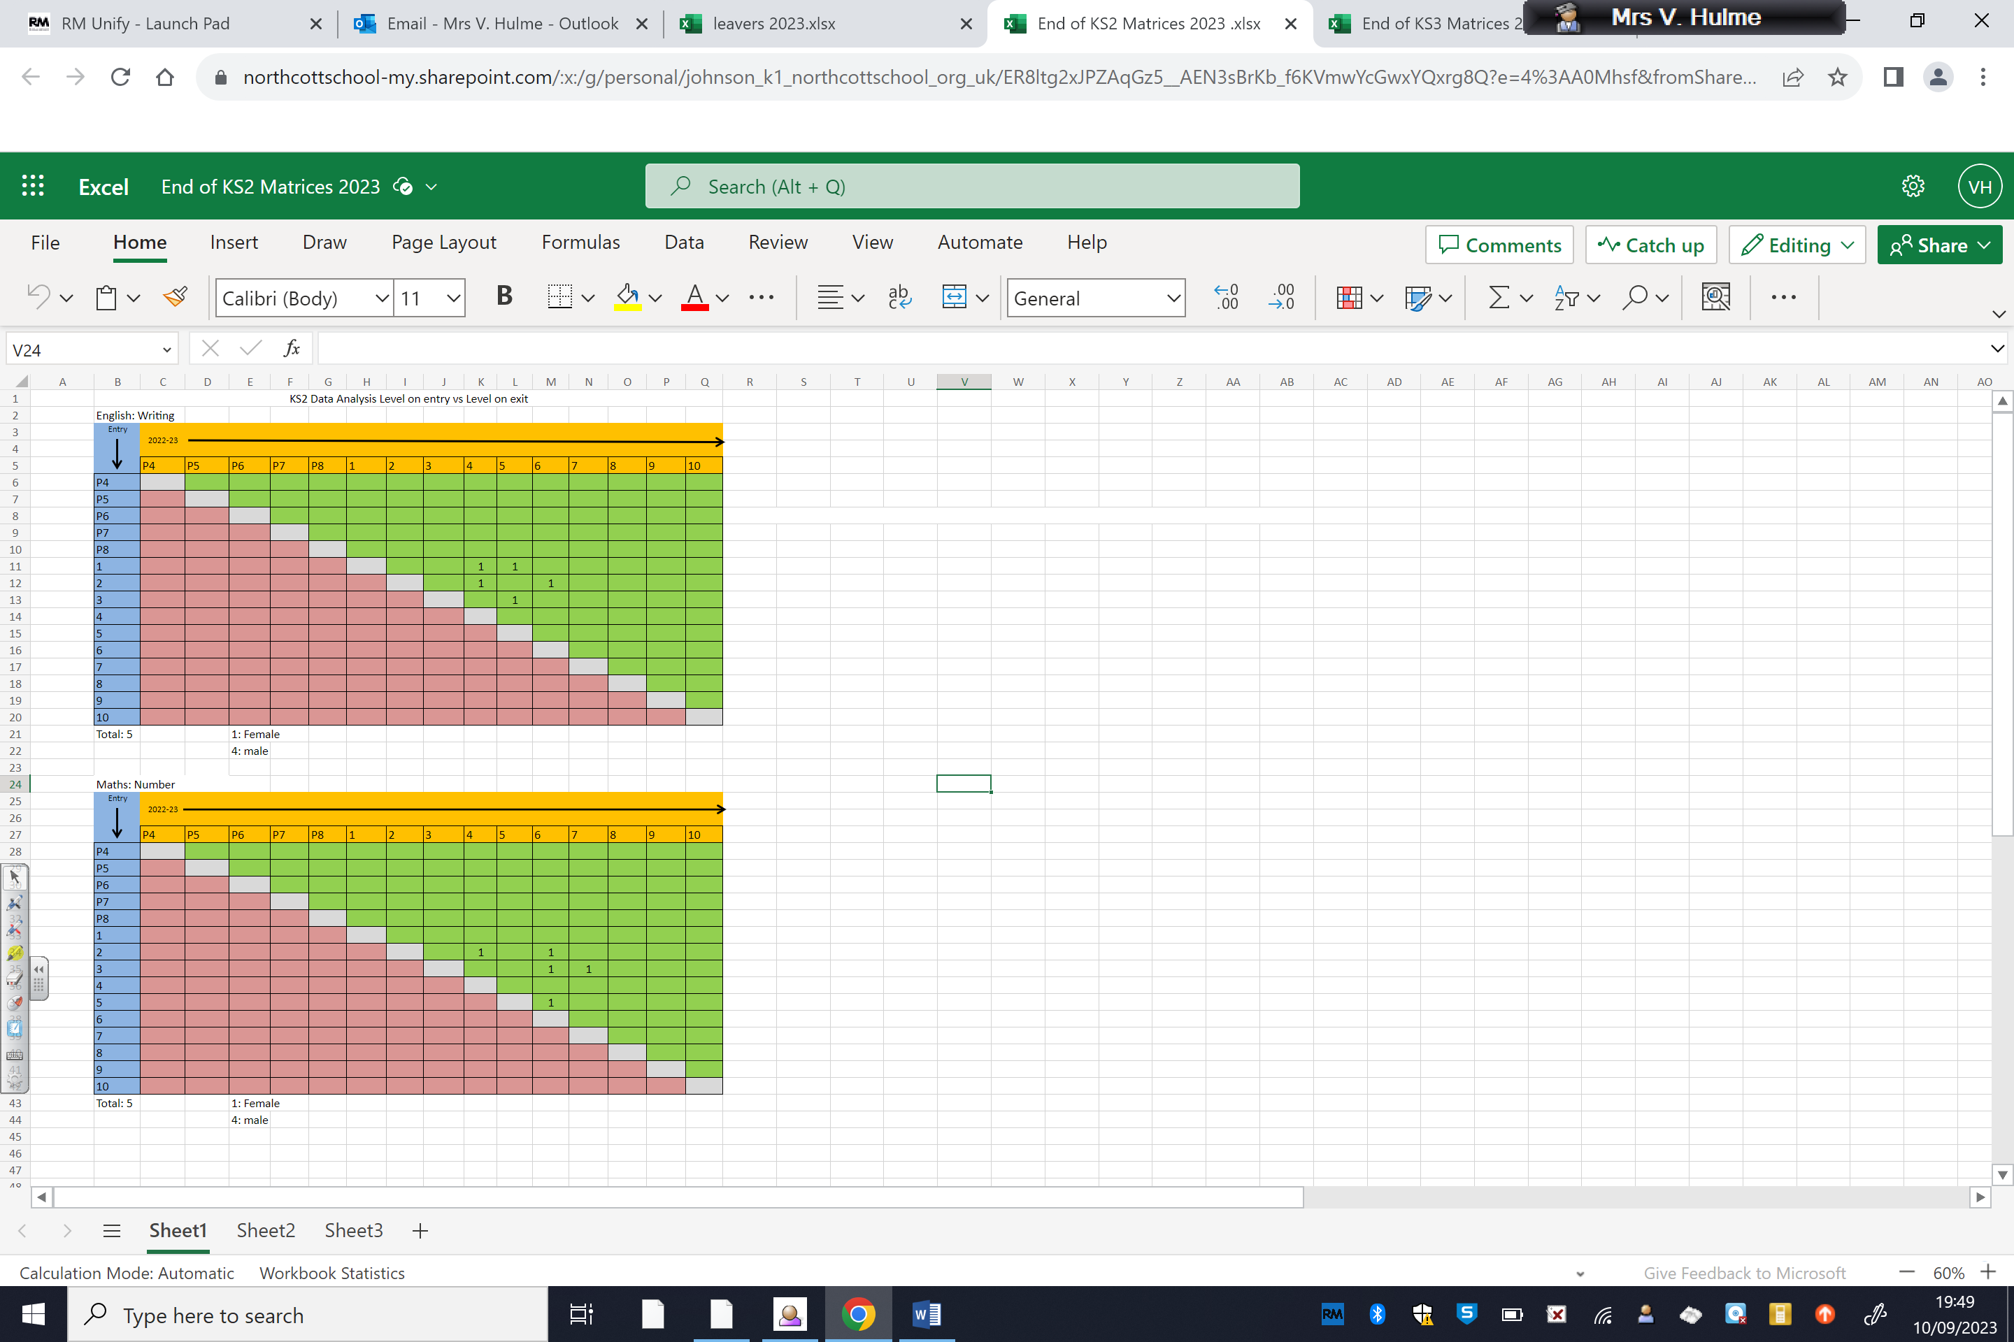

**End of Key Stage 3 Matrix analysis**

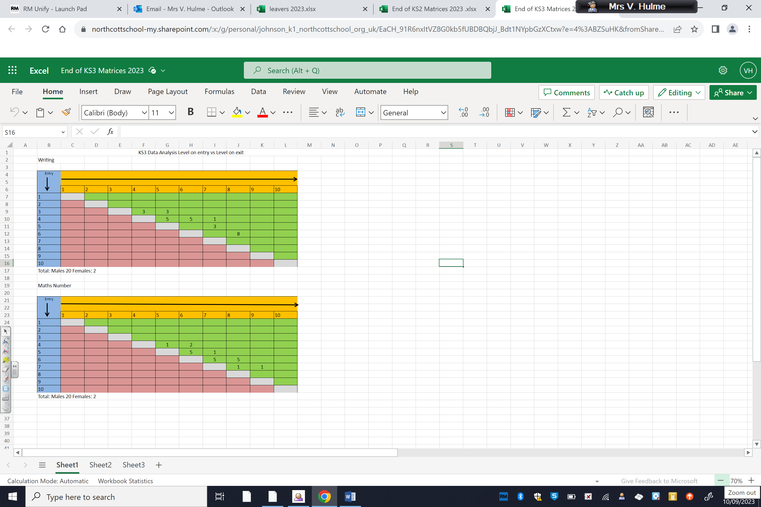

**Year 11 Analysis**

|  |  |
| --- | --- |
| Number of pupils leaving in July 2022 | 23 |
| Number of GCSE grades achieved (1-9) | 28 |
| Number of grade 4 and above GCSE grades achieved | 10 |
| Total GCSE or equivalent (GCSE grade equivalent 4-9) | 48 |
| Total GCSE or equivalent (GCSE grade equivalent 1-3) | 112 |
| Total GCSE or equivalent | 160 |
| % of pupils achieving 5 or more qualifications | 96% |
| Number of individuals qualifications achieved | 673 |
| Total number of qualifications entered | 658 |
| % of qualifications passed | 98% |
| % of pupils achieving English and Maths GCSE/equivalent (1-9) | 30% |
| % of pupils achieving English, Maths and Biology GCSE/Equivalent (1-9) | 30% |

|  |  |
| --- | --- |
| Number of CLA children | 1 |
| Number of GCSE grades achieved | 0 |
| % of pupils achieving 5 or more qualifications | 100% |
| Number of individuals qualifications achieved | 21 |
| Total number of qualifications entered | 21 |
| % of qualifications passed | 100% |

**Ability profile for Year 11 leavers**

|  |  |  |
| --- | --- | --- |
|  | Level achieved in Year 7 | Exit level achieved |
| Highest ability | 5 | 5 |
| Lowest ability | 1a | Entry Level 2 |

**Leavers Destinations 2014-2023**

|  |  |  |  |  |  |  |  |  |  |  |
| --- | --- | --- | --- | --- | --- | --- | --- | --- | --- | --- |
|  | Bishop Burton | East Riding | Hull | Ganton | Tween | OOC | Wilberforce | Other | Case | NSI/Northcott |
| dykes |
| 2014 | 2 | 10 | 3 | 7 |  | 2 |  |  |  |  |
| 2015 |  | 18 |  | 2 |  |  | 1 |  | 1 |  |
| 2016 | 1 | 4 | 3 | 3 | 1 |  |  |  |  |  |
| 2017 |  | 12 |  | 1 | 1 |  |  |  |  |  |
| 2018 | 3 | 11 | 5 |  |  |  |  | 1 |  |  |
| 2019 | 3 | 6 | 3 |  | 1 |  |  | 1 |  | 2 |
| 2020 | 3 | 10 | 3 |  |  | 3 | 1 | 1 |  | 1 |
| 2021 | 2 | 7 | 4 |  |  | 1 |  | 1 |  | 0 |
| 2022 | 9 | 8 | 3 |  |  |  |  | 2 |  | 1 |
| 2023 | 3 | 5 | 1 | 0 | 0 | 0 | 0 | 1 | 0 | 12 |

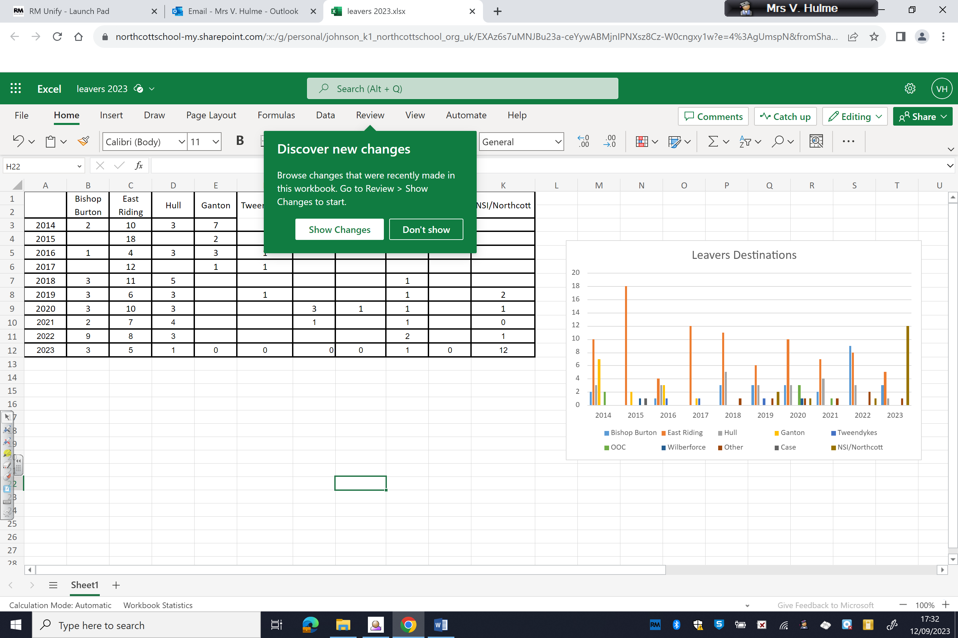

Impact of intervention

In February 2023, intervention was prioritised to pupils in Humanities in KS4, 22% were achieving 1 qualification in History and 68% were achieving 1 qualification in Geography. EOY results, 45% have 1 History, 27% have 1 Geography, 36% have History and 40% have 2 Geography.

Number was made a priority in the Primary class as 14% were making substantial progress. The end of year data shows 100% making substantial progress.

Year 7 were included in the next cycle of Maths intervention, as 4% were making substantial progress in Number. End of year data shows year 7, at 91% substantial progress in Number.

Year 8 were identified as requiring Reading intervention as only 9% were making substantial progress at the February data point. Year 8 ended the year making 100% substantial progress in Reading.

Year 9 Science data, indicated that PP pupils required a focus and in class intervention strategies as 8% of pupils were making substantial progress. End of year data shows year 9 now making 70% substantial progress.

Reading and phonics programs were introduced to Primary, Provision, Year 7 and 10a. These 4 cohorts of pupils are now the top 4 achieving groups for Reading. Primary – 100%, Provision – 83%, Year 7 – 96% and 10a 92%.

Recommendations

LAC pupils remain a priority, as this cohort is behind their peers in all areas of English and Science.

Pupils Open to Social Care will require intervention in Reading, Writing and Maths Number.

9b and VG will require intervention in Reading and Writing.

To consolidate their progress, 8a will require intervention in Reading to continue.

Girls and FSM will require intervention in Maths Number.

Understanding of the World curriculum is to be embedded in order to make the Humanities subjects more accessible for our pupils overall.

.