Quarterly Report: First Quarter 2022
Date: 31.03.22
Numbers on our database (number in bracket is last years figure)
Total number of pupils on the database | 1108 (1036)
Number of primary pupils | 685
Number of secondary pupils | 423
Number of boys | 859
Number of girls | 247
Non-Binary/Gender fluid/Agender | 2
Number of pupils with EAL | 40
Number of pupils with a diagnosis | 539
Number of pupils with an EHCP | 319
Number of pupils in red | 169
Number of pupils in yellow | 219
Number of pupils in green | 95
Number of pupils in brown | 4

Key to colour coding on the database
Red | Targeted with planned support
Amber | One off visit then possibly targeted planned support
Green | Telephone/email/planning meeting support
No colour | No support needed at this time but are discussed termly at planning meetings between Outreach and the SENDCo
Purple | Initial observation then change to one of the above colours after the initial observation
Brown | Referred as part of support for the Autism Team. These pupils are not on the pathway but the school require support in meeting their needs

Training delivered
This shows the numbers that have attended our training this quarter.
Virtual training from our offer | Virtual training booked by individual settings | Face to face booked by individual settings
317 | Hull College: 57  Stockwell Primary School lunch staff: 12 | Biggin Primary School: 20  Thorpepark Primary School: 30  Sirius West Academy: 45  Escort Primary School: 26  Marvell College: 18
Plus we have delivered the Teenlife Programme to 4 families this quarter
Additional information
This table is the total for all staff this quarter.
Number of settings visited: | Number of pupils supported: | Number of meetings attended (number of pupils involved): | Number of new referrals received: | Number of EHCNA reports written | Number of other reports written
Early Years 13 | Initial observations 83  Targeted support 336  One off 211  Other 125 | 97 (729) | Early Years 0  Primary 75  Secondary 24  College 7 | 14 | 81
Primary 248
Secondary 116
College 4

Virtual 5

Pupil absence – 34
Meetings cancelled by schools - 25
Settings cancelled visits – 15
Feedback from settings
A forms survey was sent to all settings. 53 responses were received. This is a summary of the responses:
What support have you received from the service? Tick as many boxes as apply.
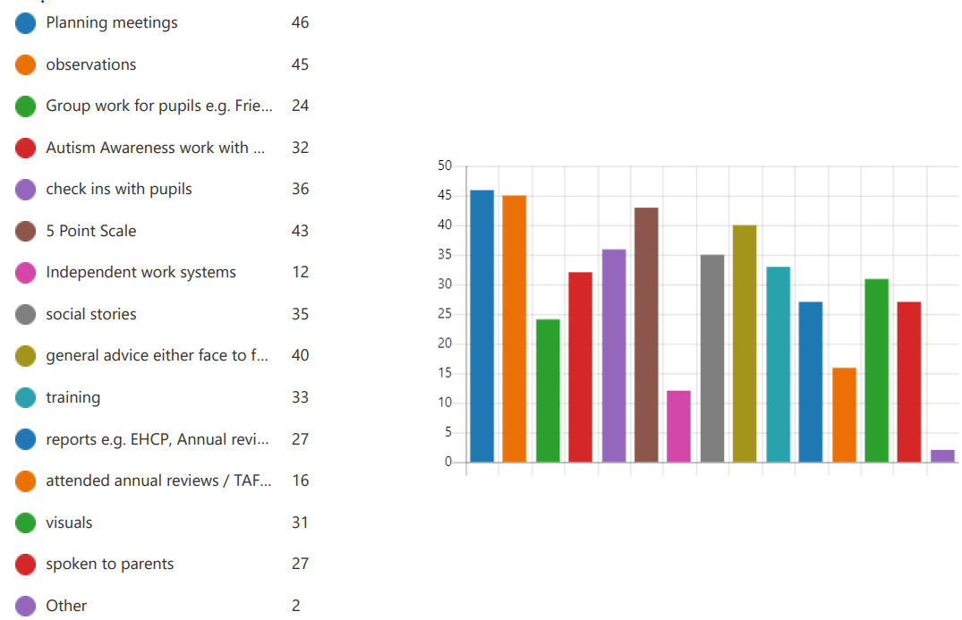
Overall how would you rate the support you have received? 5=excellent 1=poor
How would you rate the impact the support from the service has had on your pupils? 5=very positive impact 1=no impact what-so-ever?
Any other comments you would like to make:
Fantastic support and expertise!
Without the fantastic support from Northcott Outreach, I would find my job very difficult to do. They are always at the end of the line and they have provided myself, our pupils and other members of staff with advice, support and resources. I appreciate everything they do and would like to place on record that their service is invaluable to us.
The support has been amazing from all staff. Nothing is too much trouble. All staff have been a massive help.
Very supportive. Always willing to help and offer advice and guidance when and where needed.
The outreach service has been invaluable. The support they have offered both staff and students has had a huge impact. We are more than happy with the support provided.
Invaluable support and help. Thank you!
A really supportive service with highly trained professionals. I appreciate their regular support and guidance with our students and for me too as a newly trained SENDCO.
This service is invaluable to our pupils and teaching staff.
You only have to look at how many boxes I have ticked to see how marvelous the support is. It has been invaluable for ensuring the best possible outcomes for our children with ASC
We have continued to feel really supported by the team. It has been especially useful having the same members of the team getting to know our pupils and setting. Jenny and Lizzy always give us really quick responses to any queries and support with appropriate resources and training.
I cannot tell you how much we value the service that Jenny and Sarah provide - exemplary - thank you so much!
Jenny is always willing to support and answer questions and offer advice and guidance; she is great!
Thank you for your advice and support
As a new to role SENCo, I have found the advice from the staff at Northcott invaluable - thank you!
The Outreach staff who have come into school have been really good and given lots of support and advice.
I feel that the service is more effective with a mixture of online and face to face support. the addition of support staff has been fantastic.
amazing service - I work in another LA and wish I had a Northcott support team over here too!!
vital especially for supporting staff new to teaching
I always find your service extremely helpful and informative
the support we have received in school has been outstanding - especially the check ins with the children
The Outreach Service is invaluable to us as a school. The support we receive is excellent for staff and students. The staff that attend our setting are brilliant, we feel we have a really good working relationship, they are always reliable and get back back promptly to us if we ever need any guidance or support.
the support provided is invaluable, both to the school and the individual pupils
The outreach service have supported the school over the years with CPD, advice and support.
We have a very good relationship with the outreach service and our outreach workers are able to support us with a variety of questions and issues. Training is very much appreciated and bespoke training has been really helpful.
Thank you for all you do to support - it makes a very tangible to our students with ASD or those on the ASD pathway and the feedback is really helpful to support our staff in supporting the students appropriately.
Even though this is a school based support service, I wish parents had more support and contact from Northcott e.g. phone calls
Lizzy is always on hand via email to support with advice and has been great with the children.

General information
The information included in this report includes week commencing 28th March 2022. The information is only correct up to this point as things constantly change e.g. new referrals are received daily, the classification of support for individual pupils changes at least termly.
Outreach Staff
We currently have 6 members of the Outreach Team. These consist of 3 teachers and 3 support workers. Of the three teachers we have 2x 0.8 and 1x 0.6 and of the support workers we have 2x full time and 1x 0.8. Currently one 0.8 teacher and one full time support worker provide the support for the secondary settings and the other staff provide the support for the primary and early years settings.
Further information
The information above shows the number of absences from pupils we were due to visit. We have also had 25 settings cancel visits this quarter. Some of these visits may have been to see multiple pupils. This impacts on the support schools receive and due to the last minute or on occasions only finding out when we arrive at the setting it means that this becomes admin time as it is too late to re-arrange another visit.

