Northcott School 2020-2021

Data pack 2020-2021

Headline Figures
- Largest percentage of children achieving above their target is in measure, reading and number
- Highest achieving year group in S&L is Year 5
- Highest achieving year groups in reading are Year 4,5 and 6
- Highest achieving year group in writing is Year 8
- Highest achieving year groups in Maths Measure are Year 4, 6 and 10
- Highest achieving year group in Maths Number is Year 4
- Highest achieving classes in S&L are Provision and Primary
- Highest achieving classes in Reading are Provision, primary, 7a, 8a and 9a
- Highest achieving classes in writing are Provision, 8B and 9a
- Highest achieving class in maths number is 11b
- Highest achieving class in maths measure is Primary with Provision, 9b, 10a and 10b scoring in the high 90%’s

Definitions:
Sustained progress: Progress up to their End of Year target step
Substantial progress: Progress above their End of Year target step

S&L | Reading | Writing | Number | Measure
% Substantial progress total | % Substantial progress total | % Substantial progress total | % Substantial progress total | % Substantial progress total
52.1% | 68% | 52.4% | 66% | 78%

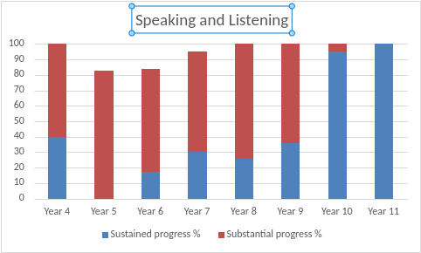
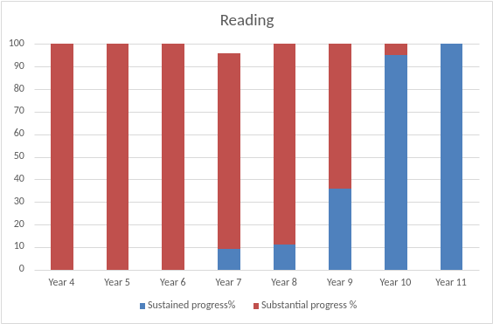

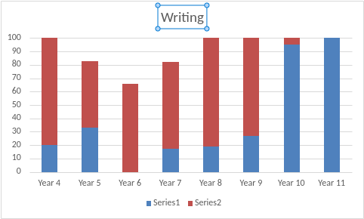

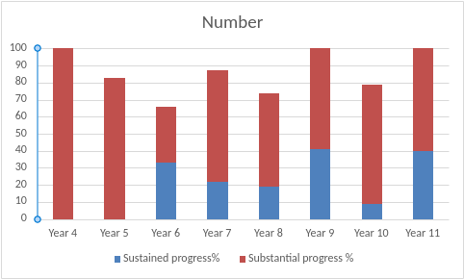

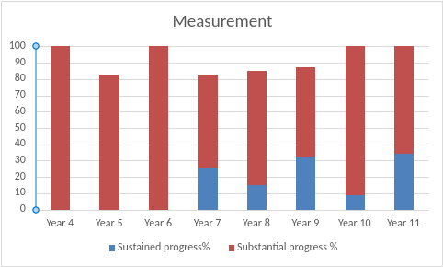
Class group comparison
 | S&L |  | Reading |  | Writing |  | Number |  | Measure
Class | On  Target  % | Above Target  % | On Target % | Above  Target  % | On Target % | Above Target  % | On Target % | Above Target % | On Target % | Above Target %
Pro | 0 | 100 | 0 | 100 | 0 | 100 | 0 | 75 | 0 | 92
Pri 1 | 27 | 55 | 0 | 100 | 27 | 45 | 18 | 82 | 0 | 100
7a | 50 | 50 | 0 | 100 | 8 | 83 | 58 | 33 | 42 | 42
7b | 78 | 11 | 22 | 66 | 33 | 33 | 11 | 66 | 11 | 56
8a | 50 | 50 | 25 | 75 | 42 | 58 | 17 | 58 | 17 | 75
8b | 8 | 92 | 0 | 100 | 0 | 100 | 24 | 42 | 25 | 58
9a | 0 | 100 | 0 | 100 | 0 | 100 | 42 | 58 | 58 | 17
9b | 67 | 25 | 67 | 25 | 58 | 42 | 50 | 50 | 0 | 92
10a | 100 | 0 | 100 | 0 | 100 | 0 | 0 | 67 | 9 | 91
10b | 91 | 0 | 91 | 0 | 91 | 0 | 18 | 64 | 9 | 91
11a | 100 | 0 | 100 | 0 | 100 | 0 | 100 | 0 | 100 | 0
11b | 100 | 0 | 100 | 0 | 100 | 0 | 10 | 90 | 0 | 100

Identified groups
 | Speaking and Listening |  | Reading |  | Writing |  | Number |  | Measure
 | Sustained progress % | Substantial progress % | Sustained progress% | Substantial progress | Sustained progress% | Substantial progress % | Sustained progress% | Substantial progress % | Sustained progress % | Substantial progress %
M | 51 | 48 | 43 | 56 | 45 | 52 | 19 | 63 | 18 | 75
F | 38 | 54 | 21 | 79 | 33 | 50 | 30 | 63 | 30 | 63
LAC | 50 | 50 | 50 | 50 | 50 | 50 | 50 | 50 | 50 | 50
NON LAC | 49 | 49 | 39 | 61 | 43 | 52 | 19 | 64 | 19 | 73
PP | 56 | 44 | 46 | 56 | 51 | 44 | 22 | 67 | 25 | 68
NONE PP | 39 | 42 | 30 | 54 | 33 | 47 | 9 | 69 | 18 | 84
FSM | 54 | 48 | 42 | 60 | 48 | 46 | 23 | 67 | 30 | 63
NON FSM | 37 | 60 | 27 | 71 | 29 | 65 | 19 | 59 | 16 | 76
SC | 48 | 52 | 11 | 47 | 43 | 57 | 25 | 57 | 17 | 76
NOT SC | 41 | 54 | 30 | 67 | 36 | 56 | 21 | 64 | 22 | 68
DISADV | 56 | 44 | 46 | 56 | 51 | 44 | 22 | 67 | 25 | 68
NOT DISADV | 39 | 42 | 30 | 54 | 33 | 47 | 9 | 69 | 18 | 84

Identified group analysis (comparing substantial progress only)

- LAC pupils perform in line with their non-LAC peers in S&L and Writing. There is a gap between performance in Reading, Number and Measure between LAC and non-LAC pupils.
- Performance of PP and Non-PP pupils is in line in all subjects, apart from Measure where non-PP pupils perform better.
- FSM pupils perform lower than their peers in English, but higher in both elements of maths.
- Social Care pupils perform in line with their peers in S&L, number and writing and significantly better than their peers in Measure.
Overall, there is no significant difference between those who are identified as disadvantaged to those identified as not disadvantaged, the only exception is in Maths Measure.

Key Stage 2 Matrix analysis

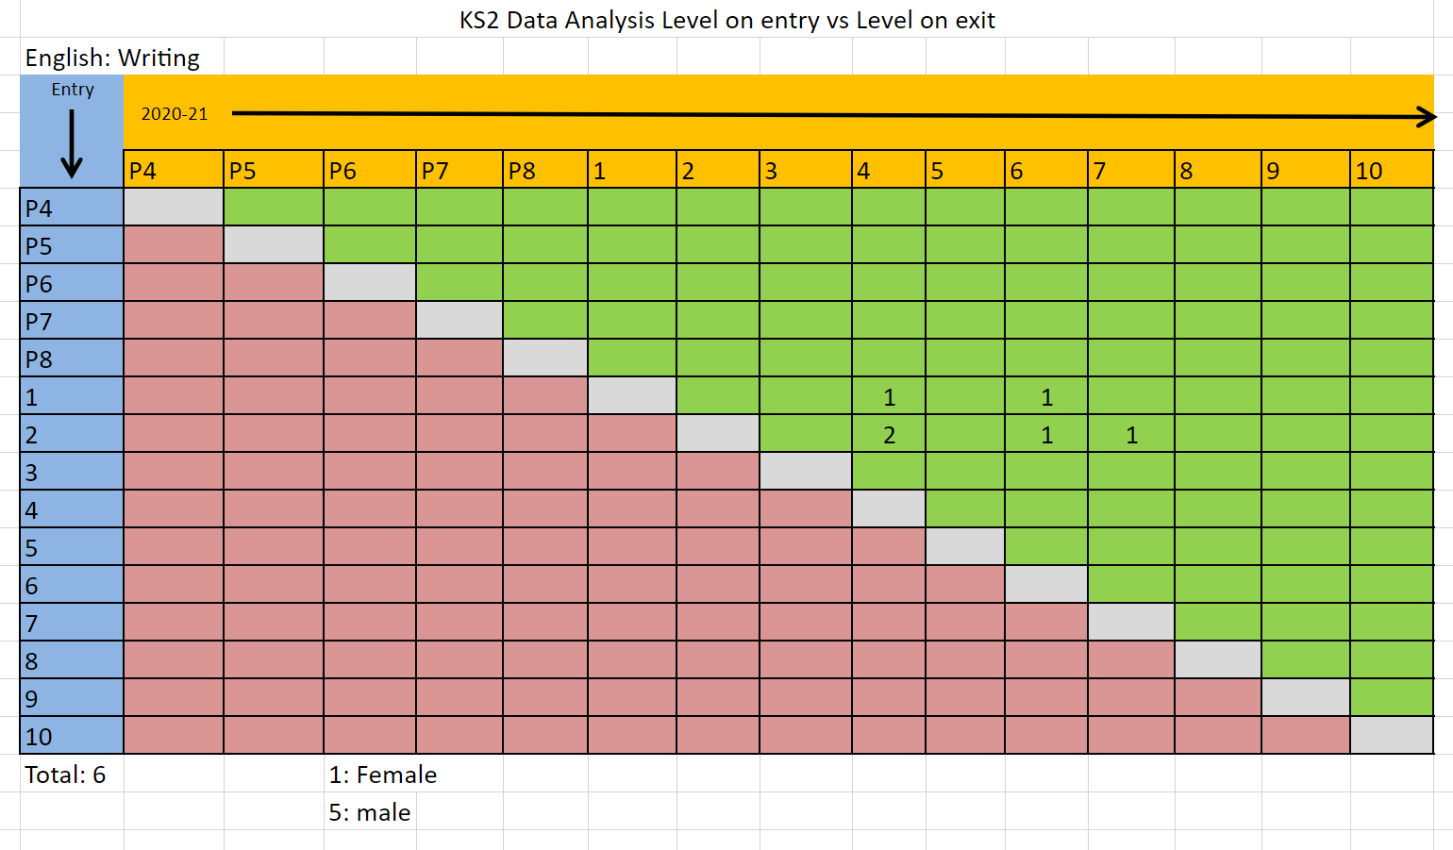

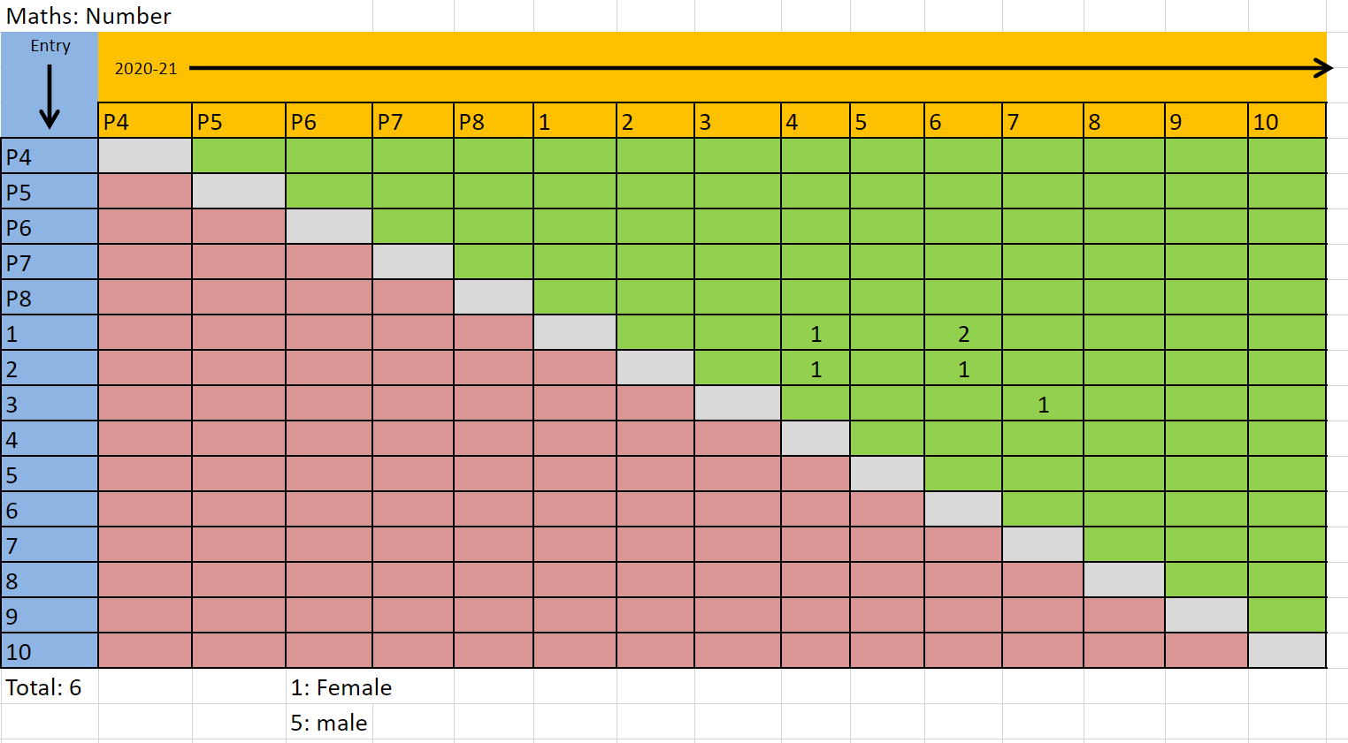
Key Stage 3 Matrix analysis
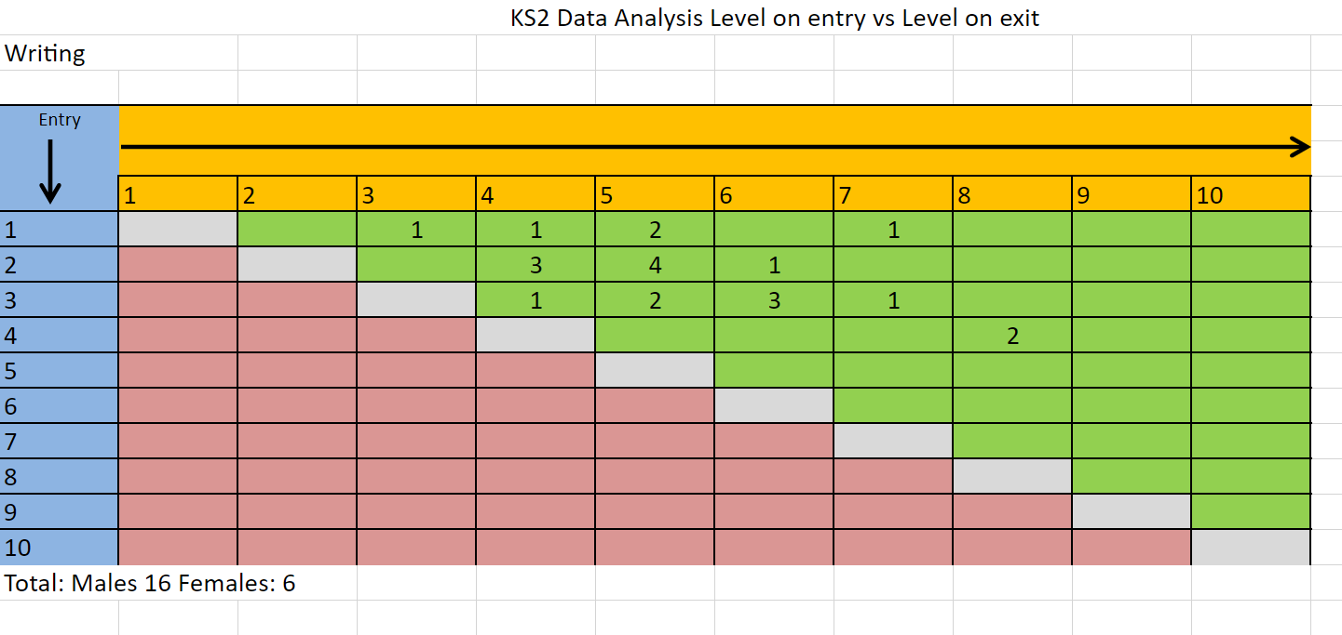
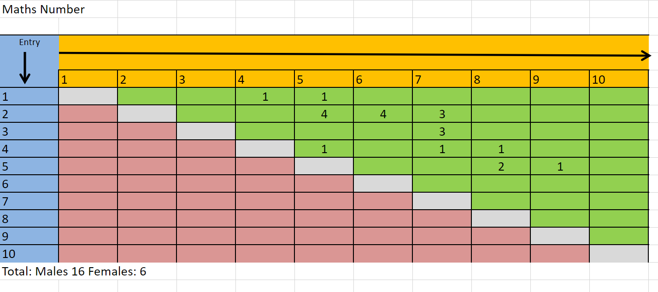
Year 11 Analysis

Number of pupils leaving in July 2021 | 15
Number of GCSE grades achieved (1-9) | 12
Number of grade 4 and above GCSE grades achieved | 3
Number of equivalent GCSE grade achieved (L2) (GCSE equivalent 4-9) | 20
Number of equivalent GCSE grades achieved (L1) (GCSE equivalent 3-1) | 15
% of pupils achieving 5 or more qualifications | 100
Number of individuals qualifications achieved | 129
Total number of qualifications entered | 150
% of qualifications passed | 86%
% of pupils achieving English and Maths GCSE/equivalent (1-9) | 33%
% of pupils achieving English, Maths and Biology GCSE/Equivalent (1-9) | 27%

Number of CLA children | 1
Number of GCSE grades achieved | 0
% of pupils achieving 5 or more qualifications | 100%
Number of individuals qualifications achieved | 6
Total number of qualifications entered | 6
% of qualifications passed | 100%

Ability profile for Year 11 leavers

 | Level achieved in Year 8 | Exit level achieved
Highest ability | 4A | GCSE Level 5
Lowest ability | 1C | Entry 2

We have not analysed by male/female due to the split of the year group, 2 female, and 13 males.

Leavers Destinations 2014-2021

 | No. of leavers | Bishop Burton | East Riding | Hull | Ganton | Tweendykes | OOC | Wilberforce | Other | Case | NSI
2014 | 24 | 2 | 10 | 3 | 7 |  | 2
2015 | 22 |  | 18 |  | 2 |  |  | 1 |  | 1
2016 | 12 | 1 | 4 | 3 | 3 | 1
2017 | 14 |  | 12 |  | 1 | 1
2018 | 21 | 3 | 11 | 5 |  |  |  |  | 1
2019 | 16 | 3 | 6 | 3 |  | 1 |  |  | 1 |  | 2
2020 | 22 | 3 | 10 | 3 | 0 | 0 | 3 | 1 | 1 | 0 | 1
2021 | 15 | 2 | 7 | 4 | 0 | 0 | 1 | 0 | 1 | 0 | 0

