Appendices Child Protection Policy 2020

Appendix 1 - Flow chart ‘what to do if you are worried a child is being abused’
Appendix 2 - Template: Case record and Chronology Form – paper version
Appendix 3 - Template: Logging a concern about a child’s safety and welfare
Appendix 4 – Template: Body Maps Guidance and Body Maps

Appendix 1
Northcott Safeguarding Flow Chart
‘What to do if you are worried a child is being abused, at risk of harm or neglect’

Member of staff, volunteer has concerns about a child’s welfare
- Be alert to signs of abuse and question unusual behaviour.

Still have concerns? Refer to EHASH (Early Help Advice Safeguarding Hub) Social Care. Have child/ families’ personal details to hand and be clear about concern/ allegations.

Consult with child young person, family and relevant agencies: Team Around Family Meeting; agree and implement support monrot,

Unmet needs identified
Decide what actions are needed to support the child.
Children’s Social Care
During Office Hour, Monday to Friday
Early Help Advice Safeguarding Hub (EHASH) Tel:- 01482 448879
If the child is at immediate risk
TEL: 101 and ask for assistance Record all decisions and actions, working to agreed outcomes and within timescales. Escalate any emerging threats/concerns by adopting Hull Safeguarding Children Partnership procedures – www.hullsafeguardingchildren.co.uk

Out of hours
Emergency
Duty Team 5.00pm – 8.30am

Tel 01482 300304

NSPCC Whistle
blowing Tel:
0800 028 0285

Safeguarding concern
Resolved /no longer held
Support has been agreed, record decision, any follow up actions.

Contacts: For any allegations/concerns regarding an adult who works with (in either paid/ voluntarily) employment with children contact the LA Designated Officer (LADO) Tel:-.
Jaquie Edhouse – LA Safeguarding Children in Education Officer Tel:- 01482 790933
This flow chart is intended as a brief guide. Please refer to our Child Protection Policy

School/Academy Child Protection/ Safeguarding Policy

Where a child or young person discloses abuse or neglect

- Listen to what they say, keep calm, reassure they are right to tell, and you will take action to help keep them safe. DO NOT DELAY take any immediate necessary action to protect the child.
- Inform them you need to share the information and what you are going to do next
- Do not promise confidentiality, you will need to share/ report the information onwards.
- Do not question further or inform the alleged abuser.

Discuss concerns with the Snr Designated/ Named Safeguarding Lead
- The Safeguarding Lead will consider further actions including consultation with Children’s Social Care/ EHASH (if a new concern).
- Concerns and discussion, decisions and reasons for decision should be recorded in writing and a ‘confidential concerns’ or ‘child protection’ file should be opened, stored in line with the school child protection policy.

Appendix 2
Case Record/Chronology CONFIDENTIAL

Sheet Number:

Complete for all incidents of concern including where a ‘logging the concern’ sheet has not been completed. If one has been completed, then add a note to this chronology to cross reference (significant information may also be added).

Name:

DOB: |  | Form:
Date | Information/Details of concerns or contact | Print Name and Signature

Appendix 3

Logging a concern about a child’s safety and welfare
Part 1 (for use by any staff)
Pupil’s Name: | Date of Birth: FORM:
Date and Time of Incident: | Date and Time (of writing):
Name:

Print Signature
Job Title:
Note the reason(s) for recording the incident.

Record the following factually: Who? What (if recording a verbal disclosure by a child use their words)? Where? When (date and time of incident)? Any witnesses?

Professional opinion where relevant (how and why might this have happened?)

Note actions, including names of anyone to whom your information was passed.

Any other relevant information (distinguish between fact and opinion).

Check to make sure your report is clear to someone else reading it.
Please give this form to your Snr Designated Safeguarding Lead
Part 2 (for use by the Snr Designated Safeguarding Lead (DSL)
Time and date information received by DSL, and from whom.

Any advice sought by DSL (date, time, name, role, organisation and advice given).

Action taken (referral to MASH/children’s social care/monitoring advice given to appropriate staff/EHAF etc. with reasons.

Note time, date, names, who information shared with and when etc.

Parent’s informed Y/N
and reasons.

Outcome

Record names of individuals/agencies who have given information regarding outcome of any referral (if made).
Where can additional information regarding child/incident be found (e.g. Pupil file, serious incident book)?
Should a concern/ confidential file be commenced if there is not already one? Why?
Signed
Printed Name

Body Map Guidance for Schools

Medical assistance should be sought where appropriate.

Body Maps should be used to document and illustrate visible signs of harm and physical injuries.

Always use a black pen (never a pencil) and do not use correction fluid or any other eraser.

Do not remove clothing for the purpose of the examination unless the injury site is freely available because of treatment.

*At no time should an individual teacher/member of staff or school be asked to or consider taking photographic evidence of any injuries or marks to a child’s person, this type of behaviour could lead to the staff member being taken into managing allegations procedures, the body map below should be used in accordance with recording guidance. Any concerns should be reported and recorded without delay to the appropriate safeguarding services,
e.g. MASH or the child’s social worker if already an open case to social care.

When you notice an injury to a child, try to record the following information in respect of each mark identified e.g. red areas, swelling, bruising, cuts, lacerations and wounds, scalds and burns:

- Exact site of injury on the body, e.g. upper outer arm/left cheek.
- Size of injury - in appropriate centimetres or inches.
- Approximate shape of injury, e.g. round/square or straight line.
- Colour of injury - if more than one colour, say so.
- Is the skin broken?
- Is there any swelling at the site of the injury, or elsewhere?
- Is there a scab/any blistering/any bleeding?
- Is the injury clean or is there grit/fluff etc.?
- Is mobility restricted as a result of the injury?
- Does the site of the injury feel hot?
- Does the child feel hot?
- Does the child feel pain?
- Has the child’s body shape changed/are they holding themselves differently?

Importantly the date and time of the recording must be stated as well as the name and designation of the person making the record. Add any further comments as required.

Ensure First Aid is provided where required and record

A copy of the body map should be kept on the child’s child protection file.

BODYMAP
(This must be completed at time of observation)

Names for Child: |  |  | Date of Birth:
Name of Worker: |  |  | Agency:
Date and time of observation:

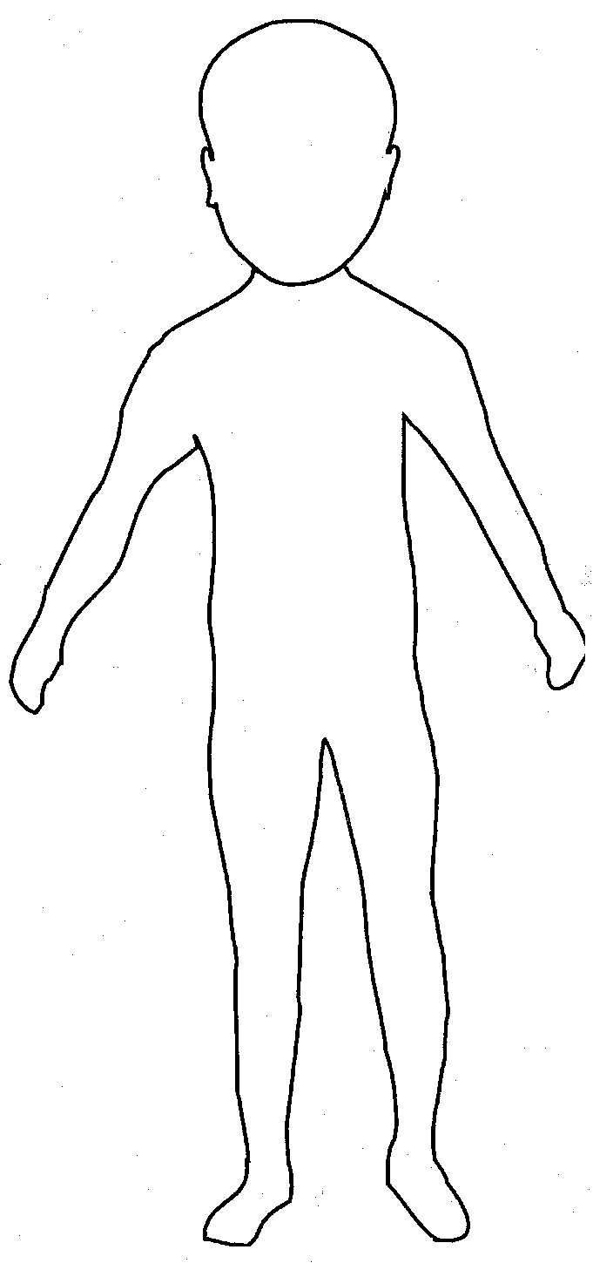 | 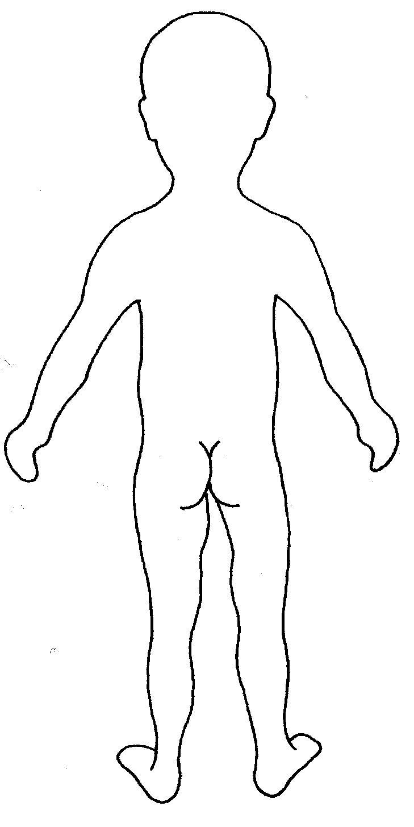

Name of Child: |  |  | Date of observation:
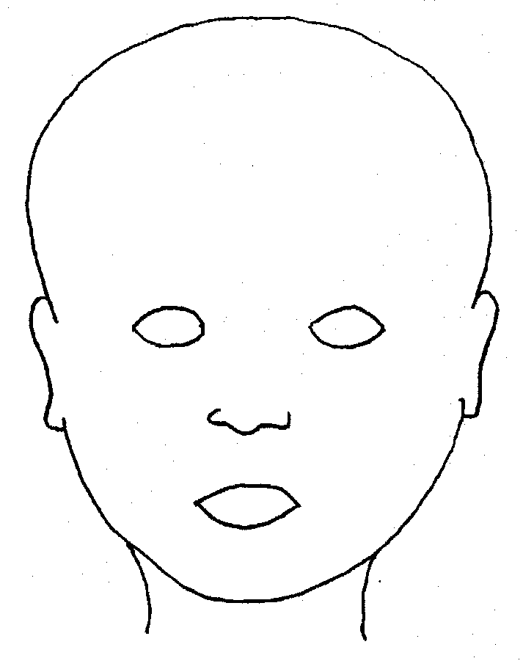
FRONT |  | BACK
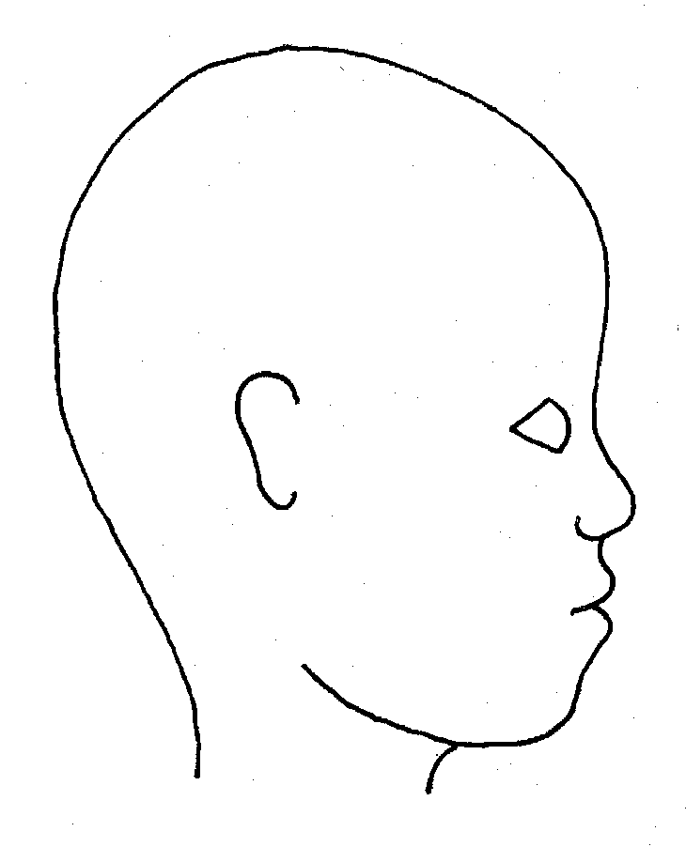 |  | 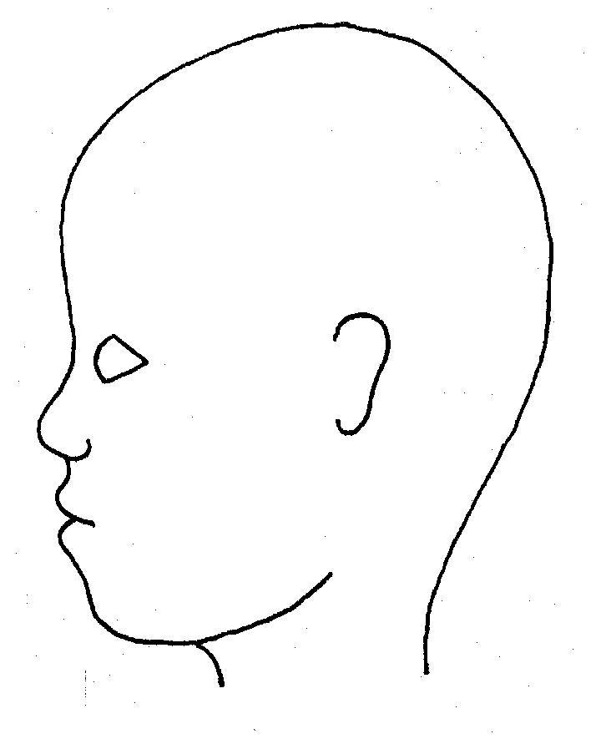
RIGHT |  | LEFT

Name of Child: |  |  |  |  |  |  |  |  |  | Date of observation:
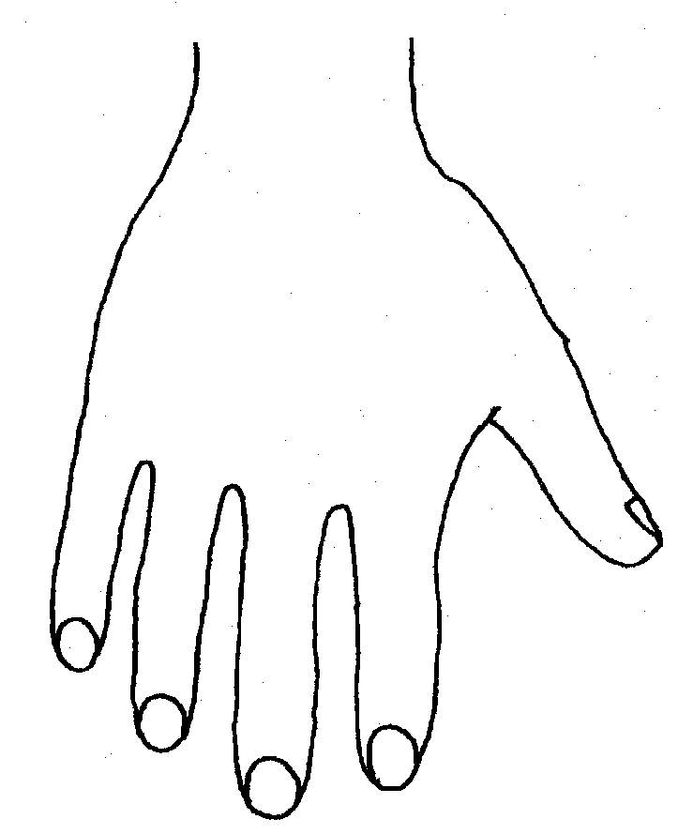 |  |  |  |  |  |  |  | 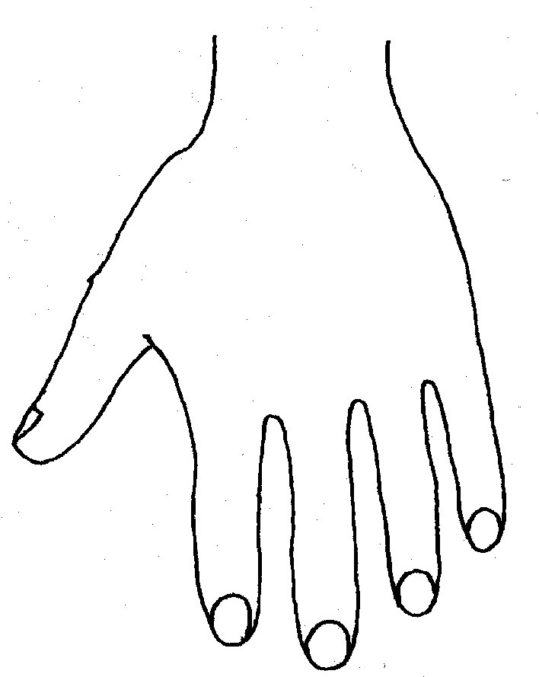
R |  |  |  |  |  |  |  | L
BACK
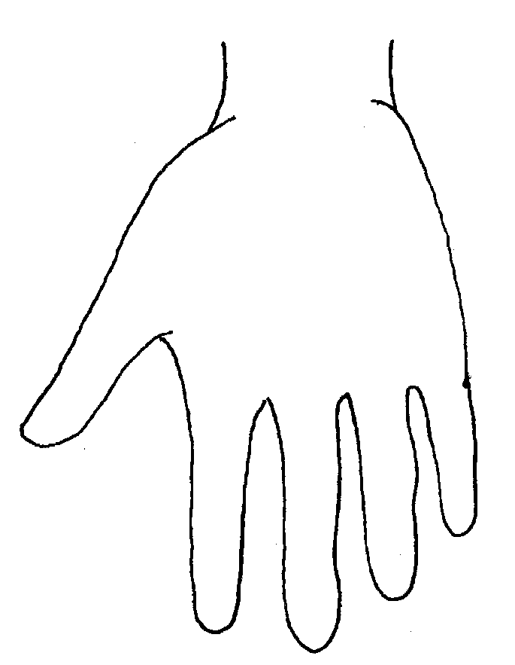 |  |  |  |  |  |  |  | 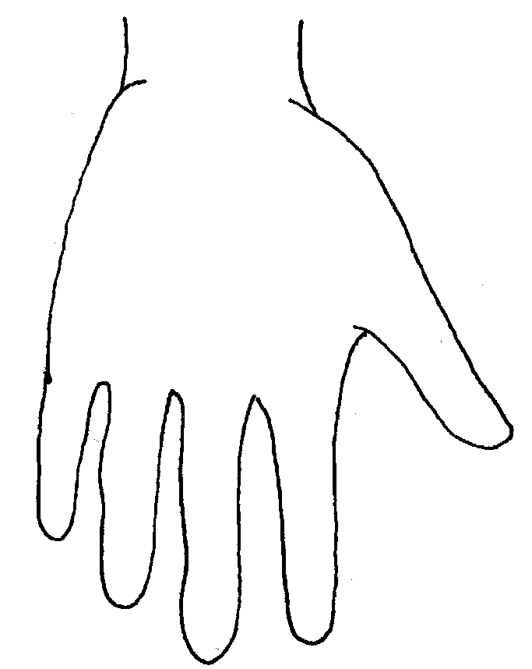
R |  |  |  |  |  |  |  | L
PALM
Name of Child: |  |  |  |  |  |  |  |  | Date of observation:
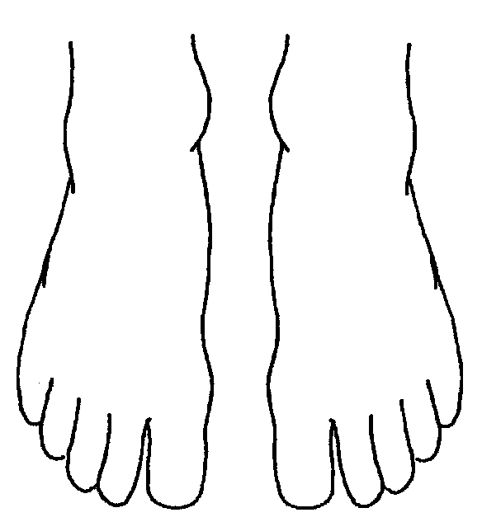 |  |  |  |  |  |  | 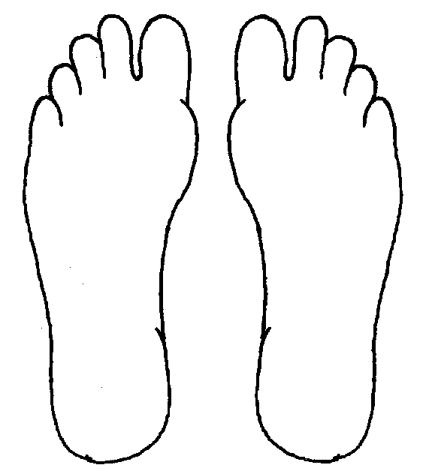
R | TOP |  |  |  |  | L | R |  |  |  | BOTTOM |  |  |  |  | L
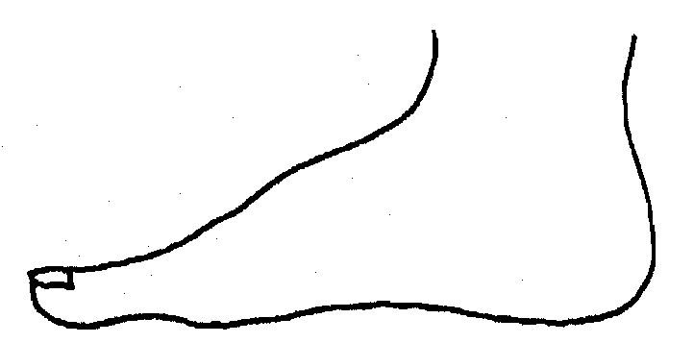
R |  |  |  |  |  |  | L
INNER
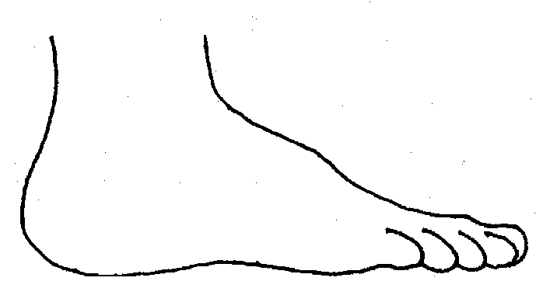 |  |  |  |  |  |  | 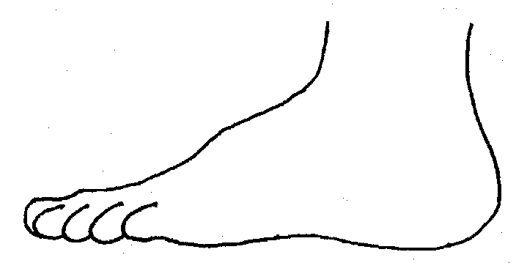
R |  |  |  |  |  |  | L
OUTER
Printed Name and Signature of worker: |  |  |  |  |  |  |  |  |  |  |  | Date:  Time:
Role of Worker
Other information:

